# Development of Arms Management System for BD ARMY

# Israth Jarin

ID: 18103167

A Practicum Report submitted in partial fulfillment of the requirements for the award of Bachelor of Computer Science and Engineering



**Department of Computer Science and Engineering**

College of Engineering and Technology

IUBAT – International University of Business Agriculture and Technology

Summer - 2023

## Development of Arms Management System For BD ARMY

### Israth Jarin

A Practicum Report submitted in partial fulfillment of the requirements for the award of Bachelor of Computer Science and Engineering

The Practicum has been examined and approved by

### Prof. Dr. Utpal Kanti Das

Chair

Department of Computer Science and Engineering

IUBAT – International University of Business Agriculture and Technology

### Dr. Hasibur Rashid Chayon

Associate Professor

Department of Computer Science and Engineering

IUBAT – International University of Business Agriculture and Technology

### Md. Saidur Rahman

Assistant Professor

Department of Computer Science and Engineering

IUBAT – International University of Business Agriculture and Technology

Summer - 2023

### Abstract

Development of Arms Management system is a web based Arms management system. The Platform will offer various function to ease up the working process. The application will also offer different modules. The application will consist of three types of users: Admin, Customer and Duty Officer. From the dashboard, the admin will be able to control the entire application. Customer and Duty Officer have some limited access. The web application is designed as per the requirements of the client. The application is developed in PHP Laravel for the backend functionalities along with MySQL as the database.

### Letter of Transmittal

16th August,2023

The Chairman,

Practicum and Placement Board, College of Engineering and Technology,

IUBAT – International University of Business Agriculture and Technology, 4 Embankment Drive Road, Sector 10, Uttara Model Town,

Dhaka 1230, Bangladesh.

**Subject**: Letter of Transmittal. Dear Sir,

With due respect, I would like to approach you that it is a great opportunity as well as immense pleasure for me to submit this report titled **“Development of Arms Management System For BD ARMY”** for the fulfillment of my Practicum course.

It was undoubtedly a splendid opportunity for me to work on this project to actualize my theoretical knowledge and has an enormous exposure with the corporate culture of a renowned company. Now I am looking forward to your kind appraisal regarding this practicum report.

I shall remain deeply grateful to you if you kindly go through this report and evaluate my performance.

Sincerely Yours,

Israth Jarin

ID: 18103167

Program: BCSE

### Student’s Declaration

I am Israth Jarin, a student of BCSE - Bachelor of Computer Science and Engineering program, under the College of Engineering and Technology (CEAT) of International University of Business Agriculture and Technology (IUBAT) declaring that, this report on the topic of **“Development of Arms Management System For BD ARMY”** has been prepared for the fulfillment of the Internship Course CSC 490, which is the partial requirement of Bachelor of Computer Science and Engineering Degree.

The report and the project on “**Development of Arms Management System For BD ARMY**” is originally prepared by me. All modules & procedures of this project were made after proper inspection and as per the requirement of the project client.

It has not been prepared for any other purpose, reward or presentation.

Israth Jarin

ID: 18103167

Program: BCSE

### Acknowledgment

In the name of ALLAH who is the most merciful and the most graceful. It’s my pleasure to takethis occasion to thank afew people, who have assisted, encouraged, directed and supported us throughout our practicum program. First of all, I want to thank my parents, who have endowed their immeasurable-innumerable support and encouragement to attain this exquisite event of my life.Then I want to honor my respect **Prof Dr Abdur Rab**, Vice Chancellor of IUBAT-International University of Business Agriculture & Technology. Then I want to honor my respected **Prof. Dr. Utpal Kanti Das**, Chairman of Computer Science and Engineering Department.

My sincere and outmost thank goes to **Dr. Hasibur Rashid Chayon**, Associate Professor of Department of Computer Science and Engineering, IUBAT- International University of Business Agriculture and Technology. For his continuous encouragement and contribution gave me the courage, the determination needed to able to finish the Internship well. I will always remain thankful for the advice and suggestion provided my Supervisor **MD. Saidur Rahman,** Assistant Professor, IUBAT This report would not have been possible without the essential and gracious support of many individuals who encouraged me to complete this project on time.

vi

### Supervisor’s Certification

This is to certify that Practicum report on **“Development of Arms Management System For BD ARMY”** has been carried out by Israth Jarin bearing ID: 18103167, of IUBAT – International University of Business Agriculture and Technology as a partial fulfillment of the requirement of Practicum Defense. The report has been prepared under my guidance and is a record of the accomplished work, carried out successfully. To the best of my knowledge and as per his declaration, no parts of this report has been submitted anywhere for any degree, diploma or certification.

Now she is permitted to submit the report. I wish her success in all of his future endeavors.

**Md. Saidur Rahman,**

Assistant Professor,

Department of Computer Science and Engineering,

IUBAT- International University of Business Agriculture and Technology

vii

### Department’s Certification

On behalf of the Department of Computer Science and Engineering of IUBAT-International University of Business Agriculture and Technology, we, the undersigned, certify that this practicum report **“Development of Arms Management System For BD ARMY”**for the award of Bachelor of Computer Science and Engineering (BCSE) degree was duly presented by Israth Jarin (ID:18103167) and accepted by the department.

**Md. Saidur Rahman,**

Assistant Professor

Department of Computer Science and Engineering

**Dr. Hasibur Rashid Chayon** Associate Professor & Coordinator

Department of Computer Science and Engineering

##### Prof. Dr. Utpal Kanti Das

Professor & Chair

Department of Computer Science and Engineering

# Table of Contents

**Abstract** iii

##### Letter of Transmittal iv

**Studen**t’**s Declaration** v

**Acknowledgment** vi

**Supervisor’s Certification** ………………...…………………………………………..… vii

**Departmen**t’**s Certification** viii

##### Internship Certificate ix

**Table of Contents** x

**List of Figures** …..……………………………..………………..…………..…………… xiv

**List of Tables** xvi

##### Chapter 01: Project Overview 1

* 1. Introduction 2
  2. Project Overview 2
  3. Background of Study 2
  4. Objectives 3
     1. Broad Objective 3
     2. Specific Objective 3
  5. Methodology 4
  6. Data Sources 4
  7. Process Model 5
  8. Reason for Choosing Waterfall Process Model 6
  9. Feasibility Study 7

* + 1. Technical Feasibility 7
    2. Economic Feasibility 8
    3. Operational Feasibility 9

##### Chapter 02:Introduction 10

* 1. Organization Introduction 11
  2. Organization Services 11
  3. The Vision 11
  4. Location and Contact 11

##### Chapter 03: Requirement Engineering 12

* 1. Requirement Analysis 13
  2. Requirement Engineering 14
     1. User Requirement 15
     2. System Requirement 16
     3. Functional Requirement 17
     4. Non-Functional Requirement 17
  3. Use Case Diagram 18

##### Chapter 04: System Planning 19

* 1. Functions of the Proposed System 20
  2. System Project Planning 20
     1. System Project Estimation 21
     2. Function Oriented Metrics …22-32
     3. Process Based Estimation 33
     4. Task Scheduling 34
     5. Project Scheduling Chart 35
     6. Cost Estimation 36
  3. Cost Estimation ….37-38

##### Chapter 05: Risk Management 39

* 1. Risk Management 40
  2. Risk Process Model 40
  3. Risk Identification 41
  4. Risk Analysis, Planning and Monitoring 42

##### Chapter 06: Analysis Modeling 43

* 1. Analysis Modeling 44
  2. Activity Diagram 44
     1. Activity Diagram for Admin 44
     2. Activity Diagram for Mechanic 45

6.2.2 Activity Diagram for Customer 46

* 1. Data Flow Diagram 47
     1. Context Level DFD 47
     2. Level 1 DFD 48
     3. Level 2 DFD (Manage User) 49
     4. Level 2 DFD (Manage Categoy) 49
     5. Level 2 DFD (Manage Brand) 50
     6. Level 2 DFD (Mange Service) 50
     7. Level 2 DFD (Manage Booking) 51
     8. Level 2 DFD (Generate Report) 51
     9. Level 2 DFD (Manage Contact)… 52

6.5 Entity Relationship Diagram 53

**Chapter 07:Designing** ……………………………..…………………………………… 54

* 1. Database Schema Design …55-58
  2. Interface Design …59-67

**Chapter 08: Quality Assurance** ………………………………….……………………… 68

* 1. System Testing 69
  2. White Box Testing Results …69-70

**Chapter 09:Conclusion** ……………………………………………..………….….……… 71

* 1. Limitation 72
  2. Future Work 72
  3. Conclusion 72

**Reference** 73

# List of Figures

Figure 1.1 Waterfall Process Model 5

Figure 3.1 Use Case Diagram 18

Figure 5.1 Risk Management Process 40

Figure 6.1 Activity Diagram for Admin… 44

Figure 6.2 Activity Diagram for Mechanic… 45

Figure 6.3 Activity Diagram for Customer 46

Figure 6.4 Context Level DFD 47

Figure 6.5 Level 1 DFD 48

Figure 6.6 Level 2 DFD (User Process) 49

Figure 6.7 Level 2 DFD (Category Process) 49

Figure 6.8 Level 2 DFD (Brand Process) 50

Figure 6.9 Level 2 DFD (Service Process) 50

Figure 6.10 Level 2 DFD (Booking Process) 51

Figure 6.11 Level 2 DFD (Report Process). 51

Figure 6.12 Level 2 DFD (Contact Process) 52

Figure 6.13 Entity Relationship Diagram 53

Figure 7.1 User Table 55

Figure 7.2 Category Table 55

Figure 7.3 Brand Table 56

Figure 7.4 Service Table 56

Figure 7.5 Booking Table 57

Figure 7.6 Contact Table 57

Figure 7.7 Full Database Table 58

Figure 7.8 Admin Login Page 59

Figure 7.9 Dashboard Page 59

Figure 7.10 Add User Page 60

Figure 7.11 Manage Category Page 60

Figure 7.12 Add Brand Page 61

Figure 7.13 Manage Service Page 61

Figure 7.14 Contact info Page 62

Figure 7.15 About Page 62

Figure 7.16 Service Page 63

Figure 7.17 Service center Page 63

Figure 7.18 Category Page 64

Figure 7.19 Contact-Us Page 64

Figure 7.20 User SignUp Page 65

Figure 7.21 User Login Page 65

Figure 7.22 Customer Booking Info Page 66

Figure 7.23 Invoice Page 66

Figure 7.24 Service Add Page 67

Figure 7.25 Service Center Report Page 67

# List of Tables

Table 1.1 Software and Hardware Requirement 8

Table 4.1 Functions of the Project 20

Table 4.2 Complexity Metrics for External Input (EI) 23

T able 4.3 Complexity Metrics for External Output and External Queries (EO / EQ) 23

Table 4.4 Complexity Metrics for Internal Logical File and External Interface File

(ILF / EIF) 23

Table 4.5 Complexity Weight Assignment for Transaction Functions 24

Table 4.6 Complexity Weight Assignment for Data Functions 24

Table 4.7 Complexity Identification for Transaction Functions 25

Table 4.8 Complexity Identification for Data Functions 28

Table 4.9 Unadjusted Function Point Contribution (Transaction Functions) 29

Table 4.10 Unadjusted Function Point Contribution (Data Functions) 30

Table 4.11 Degree of Influence 31

Table 4.12 Process Based Estimation 33

Table 4.13 Project Scheduling Chart 35

Table 4.14 Personnel Cost 36

Table 4.15 Hardware Cost 37

Table 4.16 Software Cost 37

Table 4.17 Others Cost 37

Table 4.18 Accounts Table 38

Table 5.1 Risk Identification Table 41

Table 5.2 Risk Analysis Table 42



**Chapter 01**

## Project Overview



##### Introduction

Arms management system refers to a set of procedures, tools, and technologies that a company use to keep track of and manage the Service Center. It can be utilized and implemented in a number of different ways, ranging from simple to complex. It relies on the needs and scale of the company, as well as the capabilities and utility of the management software. All businesses that deal with service need and benefit from vehicle service management software. It maintains track of all the vehicle servicing on its list and controls them.

##### Project Overview

Vehicle service management system is an application that can manage other service center under an organization or under an owner. The application consists of three type of user: Admin, Service Center and Customer. Admin is the controller of the whole process. Admin can add, delete, update category and brand and also can delete the customr and also can delete the service center pressing delete button and can see how many service center and customer are there. Admin can update brand and category also overall functionalities according to the need. Admin can generate the report for his own purpose. Service center have some access that can manage the service. Service center can add new service and also can set the price for the service. He also can update the customer service request also give the serviec to the customer. Customer can access from log in page and sign in with his account. Customer can access and can control only those function which are available to the customer. A particular customer can booking and update also delete the service request before approved by the servie center only ifthat user have the authority to do those actions.

##### Background of Study

Every service center have their systems which is controlling by the service center admin. But this project is to control all the service center under the platform admin or owner. This project was done in order to make easy for particular organization. The main advantage of this program is that it can show all service center under one platform at one place, which helps to customer to take the service from one system easily.

##### Objectives

* + 1. **Broad Objective**

The objective of this project is to increase efficiency and make management easier. Here I tried to bring most critical necessities of a vehicle service management system and combined all the service center within a platform to make it stand out and make it useful for the user.

##### Specific Objective

* + - 1. To control various service center.
      2. To provide accurate information about brand and categories.
      3. To keep track of srvice center list.
      4. Service center provide bill to the customer.

##### Methodology

The lading page will present the website with a log in and registration page. Here service center and customer can log in to their account to get access to the main frame. Admin can get his access to the main dashboard as well.

From the dashboard admin can handle the actions that are available. He can manage the user information. There is table section. Admin can view the list of user and can see which service center are available. Admin can add and manage categories, brand. Admin can see the service, category and also the brand list. Admin can edit the company profile. The Admin Dashboard is filled with such features to dynamically handle the whole website.

When Service center login to the system, can update his profile and also can create the servie with proper description and also can set the price as well. Even any kind of booking request, service center owner can responsed.

Customer can login to his profile and update it. He can request for booking and update and delete before service center take any action. Customer can get the report for his completed service and can print it also. For payment purpose, he can get the payment system option for payment.

##### Data Sources

**Primary Data** is collected from various vehicle service center to see how they operates and how they function. Which functions are more applicable and possible to achieve. **Secondary Data** is collected from different web-based service center. Where I got ideas to create the new data.

##### Process Model

I followed the Waterfall Process Model for creating the project. The Waterfall Approach was the first SDLC Model to be widely used to ensure project success in Software Engineering.

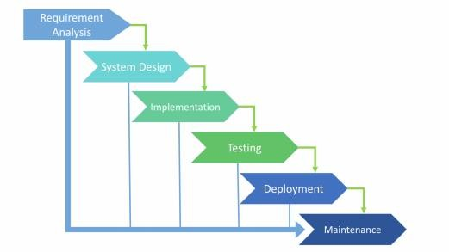

Fig 1.1: Waterfall Process Model

The sequential phases in Waterfall model are –

**Requirement Gathering and analysis** − During this phase, all possible requirements for the system to be developed are gathered and recorded in a requirement specification document.

**System Design & Implementation** − In this phase, the requirements specifications of the first phase are reviewed and the system design is completed. This engineering design helps you specify hardware and system requirements and define the overall system architecture.

**Integration and Testing** − All units developed during the implementation phase are integrated into the system after testing each unit. After integration, the entire system is tested for errors and failures.

**Deployment of system** − The goods is deployed within the client environment or released into the market once the functional and non-functional testing is completed.

**Maintenance** − Within the client environment, there are several challenges that arise. Patches are published to fix the problems. In addition, better versions of the items are created to support the merchandise. Maintenance is finished in order to provide these modifications to the customer's environment.

##### Reason for Choosing Waterfall Process Model

The main reason behind that to choose this model for my project that it’s a simple porject and the requirement is clear for me to develop. For mini project it used a lot and the requirement are not chage frequently.

Some of the main advantages of the Waterfall Model are as follows −

1. Simple and straightforward to know and use
2. Easy to manage thanks to the rigidity of the model.
3. Each phase has specific deliverables and a review process.
4. Phases are processed and completed one at a time.
5. Works well for smaller projects where requirements are alright understood.
6. Clearly defined stages.

##### Feasibility Study

A feasibility assessment examines the likelihood of a project being completed successfully. A feasibility study is created to determine if the project, once completed, will serve the organization's goals for the amount of labor effort and hence the time spent there. A feasibility study allows the developer to forecast the project's long-term viability and thus it’s utility. The feasibility study of a system proposal is consistent with its feasibility: its impact on the organization, its ability to meet user needs, and its effective use of resources. Therefore, when an alternative application is proposed, a proof of concept is usually done before the development is approved. This document provides under design and covers feasibility List.

##### Technical Feasibility

The system must first be assessed from a technological standpoint. The feasibility study must be backed up by a high-level design of the system's requirements in terms of input, output, programs, and procedures. Following the discovery of an overview system, the inquiry must continue to suggest the type of equipment, required methods for constructing the system, and methods for operating the system once it has been designed.

At the same time, the procedure of utilizing this application is simple, ensuring that users are technically capable of achieving the goals.

The project, entitled Vehicle Service Management System, is technically feasible with the following that are readily, inexpensive, and well served.

|  |  |  |
| --- | --- | --- |
| **SL** | **Hardware Requirements** | **Software Requirements** |
| 1 | Desktop Computer | OS (Any), Browser (Any) |
| 2 | Internet Support | PHP, Laravel, JavaScript, HTML5, CSS4, Authentication, API, REST API, JSON |
| 3 | 12GB system memory with 1TB HDD | MySQL |

Table 1.1: Software and Hardware Requirements

##### Economic Feasibility

Given the economical feasibility of the system I proposed, I properly analyzed and maintained the time. The cost of the system is flexible for the company. Employee time costs are reduced if the system is fully maintained by the organization. The estimated cost of hardware is about 80,000 taka & software is free.

##### Operational Feasibility

Even though I had spoken with my customer multiple times regarding the project's update, he stated his appreciation for the newly constructed system and expressed a need for it. If users have expressed a desire for a system that is available more of the time, is more efficient, and is more accessible, the chances are that the requested system will be employed ultimately. As a result, my project is developmentally realistic.

## Chapter 02 Organization Introduction

##### Organization Introduction

### Organization Overview Kodeeo Ltd. is a Bangladeshi firm that offers full-featured web solutions, software development, mobile applications, graphic and multimedia, domain hosting, and digital marketing services. Its core consists of highly trained designers and developers with more than five years of experience in a variety of intricate designs and development. With services including web design and development, mobile app design and development, software development, SEO, and social media designing and development, Kodeeo Ltd. has pleased its customers. In every area of our, operations we work hard in understanding the Client’s requirement and providing the Kodeeo Ltd solution. We firmly believe in the philosophy of ‘Our vision is to make every youth skilled & employed’. We take pride in a team of highly qualified, skilled and motivated Professionals who are encouraged to lead, innovate and excel. Our team consists of top professionals who share a common vision and passion, providing our clients with critical insights and advice to succeed in today’s competitive environment. We believe in delivering Expertise, Excellence Services through our experience and giving the highest best end use of services to our client. (Kodeeo Ltd). Organization Services Kodeeo Ltd. is a leading supplier provider of information technology services, including all types of creative and professional software, enterprise software integration, management information systems, e-commerce, game development, web development, and mobile app solutions

##### Organization Services

Kodeeo functions as a vendor enterprise for select businesses, including Skill-Interior. Kodeeo primarily offers the following core services:

Business Analysis and Consultancy

* + 1. Software Development
    2. Digital Marketing and Content Creation
    3. Integrated Campaign
    4. Maintenance and Support

### 2.3 The Vision

### Web Development :

### At Kodeeo Ltd, our primary focus revolves around the creation of websites that embody search engine friendliness, aesthetic appeal, and interactivity. Recognizing the undeniable significance of a strong online presence and the abundant marketing prospects offered by the digital realm, we understand the indispensable role that a well-crafted website plays. As we embark on the journey of designing and developing your website, our adept professionals meticulously consider key facets such as user-friendly navigation, consistent design language, high-caliber content, adherence to timelines and budgetary constraints, and robust backend support.

### Mobile Application Development :

### Our prowess extends to the realm of mobile application development, where our team of expert engineers thrives. These seasoned professionals boast a wealth of experience in constructing versatile mobile applications catering to diverse industries. With a rich history of over five years working extensively on both Android and iOS platforms, our engineers are well-equipped to deliver excellence. Our specialization lies in native Android development, ensuring swift app responsiveness and unparalleled quality. We not only conceptualize and design but also bring your ideas to life through a meticulous process encompassing planning, building, testing, and seamless deployment.

### Digital Marketing :

### In the ever-evolving digital landscape, Kodeeo Ltd emerges as a comprehensive solution provider in the realm of digital marketing. Our array of tailored packages is meticulously designed to position your company at the zenith of the online world. Digital marketing serves as the bedrock of business success, and we understand its pivotal role in brand promotion. Our efforts focus on amplifying your visibility to potential customers across the digital spectrum. A heightened online presence paves the path toward achieving your business objectives. As a full-service digital agency, Kodeeo Ltd caters to an eclectic clientele spanning from esteemed corporations to pioneering startups.

##### Location and Contact

House 15, Road-10 A, Sector 11, Dhaka 1230,Bangladesh.

Phone: +88 01854-969657

Ema[il: info@kodeeo.com](mailto:contact@ztrios.com)

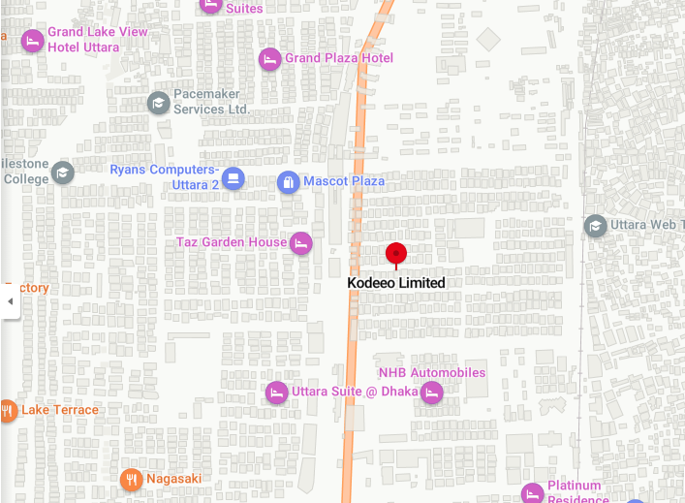

Figure 1.1 Organizational Location

**2.4 Organization Vision**

Kodeeo Ltd.'s vision is to empower young people and build a successful IT business in a digital

Bangladesh. Their mission is to become one of the top leading IT companies in Bangladesh. Through \

the creative use of technology, Kodeeo Ltd. gains a competitive edge and increases operational \

effectiveness and efficiency.

* 1. **Organization Mission**

Kodeeo Ltd. was established as a one-stop shop for a skills development platform. Client needs are

satisfied in respect to their attributes thanks to their services and the excellent staff behind them.

* 1. **My Position in this Organization**

I am an intern developer to this organization. I am guided by a supervisor in this organization. He is

very helpful and informative. I have really learned a lot from him. I have successfully completed my

project in time. It was only possible by the guidance of my supervisor. It was also a big experience to

maintain the office time for me. I also uphold the organization's other guidelines. I'm glade to be a part

of this office. It's definitely helped me get ready for the start of my profession.

* 1. **Organization Structure**

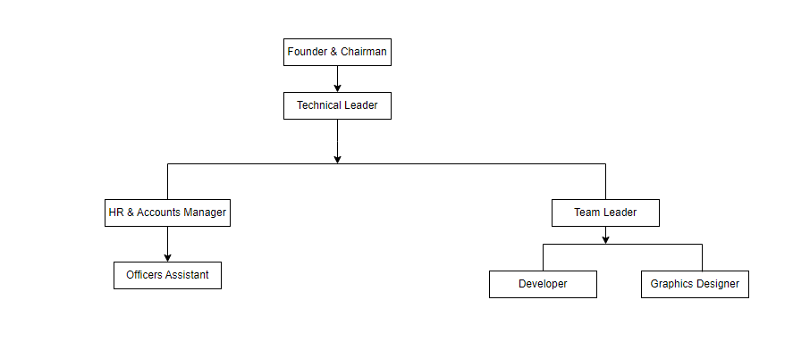

Figure 1.2 Organization structure of kodeeo (www.kodeeo.com)



## Chapter 03 Requirement Engineering

##### Requirements Analysis

Requirement analysis serves as a critical juncture within the realm of software engineering, bridging the gap

between system engineering and system design. This pivotal task empowers software developers to

delineate and construct comprehensive models encompassing information, functionality, and behavior

domains targeted by the software.

As the foremost stage in the software development process, requirement analysis entails an array of

responsibilities. These encompass the identification and definition of the prerequisites and criteria essential

for the creation of a new or refined product. This phase lays the foundation for the subsequent stages of

development, ensuring that the software's eventual construction is rooted in a thorough understanding of user

needs and system functionality.

There are 6 phases which is described below:

**Requirement Initiation:** My project entitled “Arms Management System for BD ARMY”.

**Requirement Elicitation:** Communicating consider all of their demands, and ensure that they grasp the new systems' implications. I also attempted to comprehend the user's requirements as well as the system's limitations. I examined the work of the user. Mainly two works:

* + - Analyze the Requirement
    - Recording User Requirements

**Requirement Elaboration:** This is the process of gathering information about the demands and restrictions of users. How the system's entities will interact with one another.

**Requirement Negotiation:** Here we negotiating with the customer regarding the cost of software and other equipment provided to the system.

**Requirement Specification:** The behavior of the system to be developed is described in detail in a software requirements specification (SRS). At this point, I described the manpower and technology needs for the system's deployment.

##### Requirement Engineering

Requirement is the technical field of creating user requirements and specifying software systems, as the name implies. Requirements engineering has many definitions. However, they share the idea that requirements consist of and understanding what the requirements mean from a design perspective.

There are four type of requirement:

1. User Requirements
2. System Requirements
3. Functional Requirements
4. Non-Functional Requirements

##### User Requirements

Here user requirements I have taken under consideration while doing ‘Vehicle service management system’. The user requirements are:

* + - 1. There should be an admin login page.
      2. Admin can login.
      3. Commander can login.
      4. Duty Officer can login.
      5. Admin can manage the Arms types.
      6. Admin can manage the Arms Stock.
      7. Commander can login for give firing order.
      8. Duty Officer can login for specific purpose.
      9. Admin can take action against damage stock and stock.
      10. Commander can view the Stock.
      11. Commander can view the Arms types.
      12. Commander can view the Arms setup.
      13. Commander can provide billing report to the vendor.
      14. Commander center can update profile.
      15. Commander can login.
      16. Duty Officer can login.
      17. Duty Officer can view the notice only.
      18. Admin and Duty Officer can print report.

##### System Requirement

* + - 1. System can provide Commander info.
      2. System can provide Duty Officer information.
      3. System provide the available stock list.
      4. System provide the list of tables if they are available or not
      5. System provide the list of all Arms types information.
      6. System provide the list of all Arms setup information.
      7. System provide the list of all Sailors information.
      8. System provide the list of all Vendors information.
      9. System provide the list of all Purchases information.
      10. System provide Damage stock list.
      11. System provide purchases information.
      12. System provide a reports.
      13. System should be able to edit, add and update all the given information.

##### Functional Requirement

I

* + - 1. Admin manage all the Arms types Category.
      2. Admin manage all Arms setup Category.
      3. Admin manage all Soldiers.
      4. Admin manage all Damage Stock.
      5. Admin manage all Stock.
      6. Admin manage the commander and duty officer.
      7. Admin edit his own info.
      8. Commander manage the firing order.
      9. Duty Officer manage the stock.
      10. Commander should be able to edit ,update information.
      11. Commander should be able to edit his own info.
      12. Duty Officer should be able to edit his own info.
      13. Commander should be able to view all the arms types, arms setup, stock, damage stock.

##### Non-Functional Requirement

* + - 1. Production Requirements: Arms management system should be available in pc as well as running on any OS.
      2. Organizational Requirements: Only admin can add or remove user, Stock and Damage Stock, Purchases, Soldiers, Arms types.
      3. External Requirements: System should the trustable for ensuring complete privacy for all of its users.
  1. **Use Case Diagram**

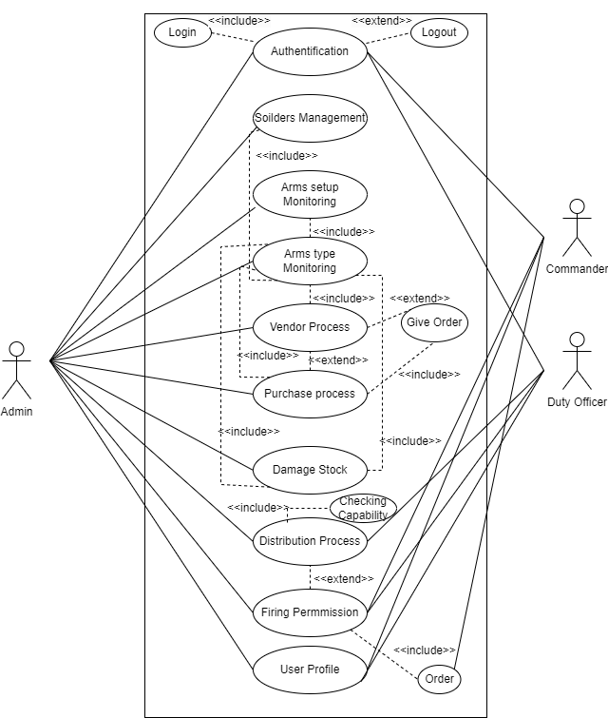

Fig 3.1: Use Case Diagram



## Chapter 04 System Planning

##### Functions of the Proposed System

Functions of the proposed system “Arms Management System For BD ARMY” are given below:

|  |  |  |
| --- | --- | --- |
| **SL** | **Functions** | **Synonym** |
| 1 | Authentication ( Login & Logout) | F1 |
| 2 | Arms setup Monitoring | F2 |
| 3 | Arms type Monitoring | F3 |
| 4 | Soldiers Management | F4 |
| 5 | Vendor Process | F5 |
| 6 | Purchase Process | F6 |
| 7 | User Profile Maintainace | F7 |
| 8 | Damage Stock | F8 |
| 9 | Distribution Process | F9 |
| 10 | Firing Permission | F10 |

Table 4.1: Functions of the Project

##### System Project Planning

We have need to keep our mind that how much time need to finish our project. CPF's second activity is software project planning. Software project management begins with a series of activities collectively referred to as software project planning. Through the planning of the software project, we estimated the work to be done, the resources required, the elapsed time from start to finish, and finally analyzed the project to determine if it was feasible.

The following activities of software project planning that Ihave followed:

* + 1. System Project Estimation
    2. Function Oriented Metrics
    3. Process Based Estimation
    4. Task Scheduling
    5. Project Schedule Chart
    6. Cost Estimation

##### System Project Estimation

The accuracy of a software project estimate predicated based on a number of things. They are-

* + - 1. Properly estimated the size of the product to build.
      2. The ability to translate the size estimation into human effort, calendar time and money.
      3. The degree to which the project plan reflects the abilities of the software team.
      4. The stability of the product requirements and the environment that supports the software engineering effort.

The most significant aspect of the software project that I had to address was software size estimation. If the software size was not properly calculated, it would result in a variety of issues such as scheduling issues, budget issues, and so on.

##### 4.2.2 Function Oriented Metrics

The following are the information domain values:

**Number of external inputs (EI)** – User inputs that provide software-specific application-related data are counted as input to distinguish them from requests.

**Number of external inquiries (EQ)** – An inquiry is described as an on-line input that results in the development of an on-line output in the form of a software response. Each enquiry was counted separately.

**Number of Internal logical files (ILF)** - Each logical master file was counted separately. The database table where the application modifies the form input.

**Numbers of external interfaces files (EIF)** - All machine-readable interfaces that previously sent information to another system were counted.

**Functional Complexity:** The complexity matrices are listed below:

Table 4.2: Complexity Metrics for External Input (EI)

|  |  |  |  |
| --- | --- | --- | --- |
| **EI** | **1-4 DETs** | **5-15 DETs** | **16 or more DETs** |
| 1 FTRs | Low | Low | Average |
| 2FTRS | Low | Average | High |
| 3 or more FTRs | Average | High | High |

Table 4.3: Complexity Metrics for External Output and External Queries (EO / EQ)

|  |  |  |  |
| --- | --- | --- | --- |
| **EO/EQ** | **1-5 DETs** | **6-19 DETs** | **20 or more DETs** |
| 1 FTRs | Low | Low | Average |
| 2-3 FTRs | Low | Average | High |
| 4 or more FTRs | Average | High | High |

Table 4.4: Complexity Metrics for Internal Logical File and External Interface File (ILF / EIF)

|  |  |  |  |
| --- | --- | --- | --- |
| **ILF/EIF** | **1-19 DETs** | **20-50 DETs** | **51 or more DETs** |
| 1 RETs | Low | Low | Average |
| 2-5 RETs | Low | Average | High |
| 6 or more FTRs | Average | High | High |

##### Functional Component Complexity Weight Assignment

Table 4.5: Complexity Weight Assignment for Transaction Functions

|  |  |  |
| --- | --- | --- |
| **Complexity** | **Transaction Function Types** | |
| **EI/EQ** | **EO** |
| Low | 3 | 4 |
| Average | 4 | 5 |
| High | 6 | 7 |

Table 4.6: Complexity Weight Assignment for Data Functions

|  |  |  |
| --- | --- | --- |
| **Complexity** | **Data Function Types** | |
| **ILF** | **EIF** |
| Low | 7 | 5 |
| Average | 10 | 7 |
| High | 15 | 10 |

#### 

##### Identifying Complexity for Transition Functions

Table 4.7: Complexity Identification of Transition Functions

|  |  |  |  |
| --- | --- | --- | --- |
| **Transition Function** | **Fields/File Involvement** | **FTRs** | **DETs** |
| Login (EI) | Fields: Email, Password Files: Users | 1 | 2 |
| Logout (EI) | Fields: Email, Password Files: Users | 1 | 2 |
| Profile Update (EI) | Fields: Name, Phone, Email, Address, Password, Image, Corps, ID Number  Files: Users | 1 | 8 |
| Profile View (EO) | Fields: Name, Phone, Email, Address, Image, Corps, ID Number  Files: Users | 1 | 7 |
| Arms Setup View (EO) | Fields: Name, Status, Specification Files: Arms Setup | 1 | 3 |
| Arms Setup Add (EI) | Fields: Name, Specification, Status, Image  Files: Arms Setup | 1 | 4 |
| Arms Setup Update (EI) | Fields: Name, Specification, Status, Image  Files: Arms Setup | 1 | 4 |
| Arms Setup Delete (EI) | Fields: Name, Specification, Status, Image  Files: Arms Setup | 1 | 4 |
| Arms Type View (EO) | Fields: Type Name, Description, Status, Image  Files: Arms Type | 1 | 4 |
| Arms Type Add (EI) | Fields: Type Name, Description, Status, Image  Files: Arms Type | 1 | 4 |
| Arms Type Update (EI) | Fields: Type Name, Description, Status, Image  Files: Arms Type | 1 | 4 |
| Arms Type Delete (EI) | Fields: Type Name, Description, Status, Image  Files: Arms Type | 1 | 4 |
| Damage Stock View (EO) | Fields: Purpose, Submission Date  Files: Damage Stock, Users | 2 | 2 |
| Damage Stock Add (EI) | Fields: Purpose, Submission Date, Amount  Files: Damage Stock, Users | 2 | 3 |
| Damage Stock Update (EI) | Fields: Purpose, Submission Date, Amount  Files: Damage Stock, Users | 2 | 3 |
| Damage Stock Delete (EI) | Fields: Purpose, Submission Date, Amount  Files: Damage Stock, Users | 2 | 3 |
| Rank View (EO) | Fields: Name, Image, Status  Files: Users | 1 | 3 |
| Stock View (EO) | Fields: Available Arms Name, Status  Files: Users | 1 | 2 |
| Stock Add (EI) | Fields: Available Arms Name, Status  Files: Users | 1 | 2 |
| Stock Update (EI) | Fields: Available Arms Name, Status  Files: Users | 1 | 2 |
| Stock Delete (EI) | Fields: Available Arms Name, Status  Files: Users | 1 | 2 |
| Authorized Officer View (EO) | Fields: Name, Image, Notice, Status  Files: Users | 1 | 3 |
| Authorized Officer Add (EI) | Fields: Name, Image, Address, Email, Password, Role, Status  Files: Users | 1 | 7 |
| Authorized Officer Update (EI) | Fields: Name, Image, Address, Email, Password, Role, Status  Files: Users | 1 | 7 |
| Authorized Officer Delete (EI) | Fields: Name, Image, Address, Email Role, Status  Files: Users | 1 | 6 |
| Vendor View (EO) | Fields: Vendor Name, Address, Email, Phone  Files: Users, Vendor | 1 | 4 |
| Vendor Update (EI) | Fields: Vendor Name, Address, Email, Phone  Files: Users, Vendor | 1 | 4 |
| Vendor Delete (EI) | Fields: Vendor Name, Address, Email, Phone  Files: Users, Vendor | 1 | 4 |
| Purchase View (EO) | Fields: Name, Amount, Description  Files: User | 1 | 3 |
| Purchase Add (EI) | Fields: Fields: Name, Price, Amount, Description  Files: User | 1 | 4 |
| Purchase Update (EI) | Fields: Name, Price, Amount, Description  Files: User | 1 | 4 |
| Purchase Delete(EI) | Fields: Name, Price, Amount, Description  Files: User | 1 | 4 |

##### Identifying Complexity for Data Function

Table 4.8: Complexity Identification of Data Function

|  |  |  |  |
| --- | --- | --- | --- |
| **Data Function** | **Fields/File Involvement** | **RETs** | **DETs** |
| Users (ILF) | Fields: Name, Email, Phone, Address, Password, Image  Files: Admin | 1 | 6 |
| Arms Setup (ILF) | Fields: Name, Status, Description, Image  Files: Admin | 1 | 4 |
| Arms Type (ILF) | Fields: Name, Status, Description, Image  Files: Admin | 1 | 4 |
| Damage Stock (ILF) | Fields: Purpose, Submission Date, Amount  Files: Admin | 1 | 3 |
| Stock  (ILF) | Fields: Available Arms Name, Status  Files: Admin | 1 | 1 |
| Authorized officer (ILF) | Fields: Name, Image, Address, Email, Password, Role  Files: Admin | 1 | 6 |
| Vendor (ILF) | Fields: Vendor Name, Address, Email, Phone  Files: Admin | 1 | 4 |
| Purchase (ILF) | Fields: Name, Price, Amount, Description  Files: Admin | 1 | 4 |

##### Unadjusted Function Point Contribution

Table 4.9: Unadjusted Function Point Contribution (Transition Function)

|  |  |  |  |  |
| --- | --- | --- | --- | --- |
| **Transition Function** | **FTRs** | **DETs** | **Complexity** | **UFP** |
| Login (EI) | 1 | 2 | Low | 3 |
| Logout (EI) | 1 | 2 | Low | 3 |
| View Profile (EO) | 1 | 5 | Low | 4 |
| Update Profile (EI) | 1 | 8 | Low | 3 |
| View Arms Setup (EI) | 1 | 4 | Low | 3 |
| Add/Delete/Update Arms Setup (3 x EI) | 1 | 4 | 3x Low | 5 |
| View Arms Type(EO) | 1 | 4 | Low | 4 |
| Add/Delete/Update Arms Type  (3 x EI) | 1 | 4 | 3x Low | 5 |
| Add/Delete/Update Damage Stock (3 x EI) | 2 | 3 | 3x Low | 5 |
| Add/Delete/Update Stock (3 x EI) | 1 | 2 | 3x Average | 7 |
| Add/Delete/Update Authorized Officer(3 x EI) | 1 | 7 | 3x High | 9 |
| Add/Delete/Update Vendor  (2 x EI) | 1 | 4 | 2x Low | 7 |
| Add/Delete/Update Purchase | 1 | 4 | 2x Low | 5 |
| Total | | | | 63 |

Table 4.10: Unadjusted Function Point contribution (Data Function)

|  |  |  |  |  |
| --- | --- | --- | --- | --- |
| **Data Function** | **RETs** | **DETs** | **Complexity** | **UFP** |
| Users (ILF) | 2 | 7 | Low | 7 |
| Arms Setup (ILF) | 1 | 4 | Low | 7 |
| Arms Type(ILF) | 1 | 5 | Low | 7 |
| Stock (ILF) | 2 | 3 | Low | 7 |
| Damager Stock (ILF) | 2 | 3 | Low | 7 |
| Authorized officer (ILF) | 1 | 6 | Low | 7 |
| Vendor (ILF) | 1 | 6 | Low | 7 |
| Purchase (ILF) | 1 | 5 | Low | 7 |
| Total | | | | 49 |

##### Total Degree of Influence (TDI)

Table 4.11: Degree of Influence

|  |  |  |
| --- | --- | --- |
| **SL** | **GSC** | **DI** |
| 1 | Data Communications | 3 |
| 2 | Distributed Data Processing | 0 |
| 3 | Performance | 3 |
| 4 | Heavily Used Configuration | 2 |
| 5 | Transaction Rate | 2 |
| 6 | Online Data Entry | 3 |
| 7 | End-User Efficiency | 4 |
| 8 | Online Update | 0 |
| 9 | Complex Processing | 1 |
| 10 | Reusability | 0 |
| 11 | Installation Ease | 2 |
| 12 | Operational Ease | 2 |
| 13 | Multiple Sites | 0 |
| 14 | Facilitate Change | 0 |
| **Total** | | 22 |



TDI (Range 0 to 70) Influence size by +/- 22% = 22

##### Adjusted Function Point Calculation

VAF = (0.65 + (0.01 * TDI))

= (0.65 + (0.01 * 22))

= 0.87

Now,

UFP = UFP (Transition Functions) + UFP UFP = 63 + 49

UFP = 112

The project is developed in PHP Laravel. Hours per Function Point of PHP is 15.5. Each person will work 8 hours per day.

So, Effects for PHP = AFP*Productivity

≈ 112 x 15.5

≈ 1736 per hour

12 hour person/per day = 1736/12

Approximate 146 days

In a group, there are 2 members

= 146/2

= 73 days Working 25 days a month.

= 73/25 =>2.92months

##### Process Based Estimation

##### 

In this section I show that in which particular part take how much time & percentage to

complete the whole system: The estimation table given below:

|  |  |  |  |  |  |  |  |  |
| --- | --- | --- | --- | --- | --- | --- | --- | --- |
| **Activity** | **CC** | **Planning** | **Engineering** | | **Construction** | | **Implementation** | **Total** |
| **Function** | **Analysis** | **Design** | **Code** | **Test** |
| **F1** | 0.32 | 0.02 | 0.163 | 0.065 | 0.197 | 0.118 | 0.045 | **0.46** |
| **F2** | 0. 32 | 0. 02 | 0. 163 | 0. 065 | 0. 197 | 0. 118 | 0. 045 | **0.28** |
| **F3** | 0. 32 | 0. 02 | 0. 163 | 0. 065 | 0. 197 | 0. 118 | 0. 045 | **1.1** |
| **F4** | 0. 32 | 0. 02 | 0. 163 | 0. 065 | 0. 197 | 0. 118 | 0. 045 | **1.1** |
| **F5** | 0. 32 | 0. 02 | 0. 163 | 0. 065 | 0. 197 | 0. 118 | 0. 045 | **1.38** |
| **F6** | 0. 32 | 0. 02 | 0. 163 | 0. 065 | 0. 197 | 0. 118 | 0. 045 | **2.76** |
| **F7** | 0. 32 | 0. 02 | 0. 163 | 0. 065 | 0. 197 | 0. 118 | 0. 045 | **1.66** |
| **F8** | 0. 32 | 0. 02 | 0. 163 | 0. 065 | 0. 197 | 0. 118 | 0. 045 | **0.46** |
| **F9** | 0. 32 | 0. 02 | 0. 163 | 0. 065 | 0. 197 | 0. 118 | 0. 045 | **1.1** |
| **F10** | 0. 32 | 0. 02 | 0. 163 | 0. 065 | 0. 197 | 0. 118 | 0. 045 | **2.3** |
| **Total** | **0.46** | **0.28** | **1.1** | **1.38** | **2.76** | **1.66** | **0.64** | **9.2** |
| **Effort** | **5%** | **3%** | **25%** | **30%** | **10%** | **18%** | **7%** | **100%** |

Table 4.12 Process Based Estimation

##### Task Scheduling

When it comes to project scheduling, there are a few basic guidelines to follow. They are as follows –

**Compartmentalization** – The project needs to be broken down into manageable activities and tasks.

**Interdependence** – First need to determine the interdependence of each subdivided activity or task. Some tasks need to be run sequentially, while others can be run in parallel.

**Defined responsibilities** – Every scheduled task should be assigned to a specific team member.

**Defined outcomes** – Every scheduled work should have a clear goal in mind. Typically, the result is a work product or a portion of a work product.

##### Effort Distribution

### The software development project utilizes the project estimating approach to determine the required number of project units. For allocation of effort, the 40-20-40 rule is followed, suggesting that 20% of the effort is dedicated to coding, 40% to backend testing, and the remaining 40% to frontend analysis and design. It should be noted that this rule serves as a general guideline.

### Interestingly, in this particular project, the analysis and design phase has consumed 46% of the total development time, while coding accounted for 36%, leaving the final 18% for testing and support activities.

Table 4.13 Effort Distribution

##### Project Scheduling Chart

The following is a timeline for this project:

Table 4.14: Project Scheduling Chart

|  |  |  |  |  |  |  |  |  |  |  |  |  |  |  |  |  |
| --- | --- | --- | --- | --- | --- | --- | --- | --- | --- | --- | --- | --- | --- | --- | --- | --- |
| Week Activities | W 1 | W 2 | W 3 | W 4 | W 5 | W 6 | W 7 | W 8 | W 9 | W 10 | W 11 | W 12 | W 13 | W 14 | W 15 | W 16 |
| Requirements Analysis |  | |  |  |  |  |  |  |  |  |  |  |  |  |  |  |
| System Design |  |  |  | | | | |  |  |  |  |  |  |  |  |  |
| Implementation |  |  |  |  |  |  |  |  | |  |  |  |  |  |  |  |
| Testing |  |  |  |  |  |  |  |  |  |  |  |  |  |  |  |  |
| Deployment |  |  |  |  |  |  |  |  |  |  |  | | | | | |

#### 

##### Cost Estimation

To estimate the cost for my project & several type of cost have to develop a system. Like software, hardware, personal & other cost have for a development a system.

##### Personnel Cost

Need to developed the project = 90 days Holiday = 30 days

Working days = 90-30 = 60 days

Per months to develop = 60/3 = 20 days Per day work = 8 hours

Working hours every month = 20*8 = 160 hours

Table 4.15: Personnel cost

|  |  |  |  |
| --- | --- | --- | --- |
| **Type** | **Members** | **Duration** | **Honorarium** |
| Analyst & Designer | 1 | 3 Months | 20,000 BDT |
| Developer | 1 | 3 Months | 20,000 BDT |
| Tester | 1 | 3 Months | 10,000 BDT |
| **Total** | | | **50,000 BDT** |

##### Hardware Cost

Cost of the computers that was used to complete the project:

Table 4.16: Hardware Cost

|  |  |  |  |  |  |
| --- | --- | --- | --- | --- | --- |
| **Device** | **Quantity** | **Price** | **Lifetime** | **Using Year** | **Deprecation**  **Cost** |
| Acer  Desktop | 2 | 38,000/= | 5 Years | 3rd Year | 3*(38,000*20%)  = 22,000 BDT |
| **Total** | | | | | **33,000 BDT** |

##### Software Cost

Table 4.17: Software Cost

|  |  |
| --- | --- |
| **Description** | **Price** |
| Windows OS | Free |
| VS Code Editor | Free |
| Others | Free |
| **Total** | **0/=** |

##### Other Cost

Table 4.18: Other Cost

|  |  |
| --- | --- |
| **Description** | **Price** |
| Electricity | 8,000 BDT |
| Internet | 5,000 BDT |
| Others | 5,000 BDT |
| Total | 18,000 BDT |

##### Costing

Table 4.19: Accounts Table

|  |  |
| --- | --- |
| **Description** | **Cost** |
| Personal Cost | **50,000** BDT |
| Hardware Cost | 33,000 BDT |
| Software Cost | Free |
| Other Cost | 18,000 BDT |
| **Total Cost** | **101,000 BDT** |



## Chapter 05 Risk Management

##### Risk Management

In the Arms Management System project, we used risk management techniques to identify, mitigate, manage and control the risk that may occur during the process of software building or those that follows afterwards. We are attempting to identify the hazards that may arise throughout the project's development in this project. Additionally, attempt to come up with a means to avoid such risks, and if they do occur, devise a plan to mitigate the harm.

##### Risk Process Model

For Arms Management System these are the four steps we will deal with in risk engineering:

* + - Risk Identification
    - Risk Analysis
    - Risk Planning
    - Risk Monitoring

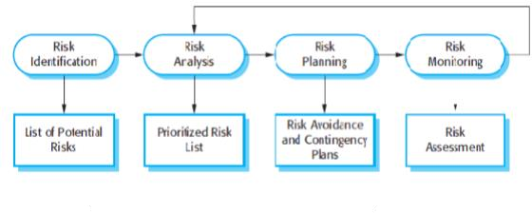

Fig 5.1: Risk Management Process

##### Risk Identification

Table 5.1: Risk Identification Table

|  |  |
| --- | --- |
| **Risk Type** | **Possible risks** |
| People | 1. Team members may struggle to comprehend the provided requirements. 2. During the project's progress, any member may become ill. 3. It's possible that the group's required training will be unavailable.   5) The group members' lack of experience.  4) There is a lack of communication among the members of the organization. |
| Technology | 1. It's possible that the database won't be able to handle many entries at the same time. 2. The system's fundamental modules may have dependency-related issues, which reduces the system's reusability. 3. The processing power of the available workstations may not be sufficient to complete the job. |
| Requirements | 1. Requirements may change after the construction of fundamental features,   necessitating a complete rewrite of the entire system's functionality.   1. A requirement change may be proposed that affects the entire system components' internet work. |
| Estimation | 1. The project's estimated development time may be shorter than anticipated. 2. The budgeted amount may not be sufficient for the entire project's development. |



##### Risk Analysis, Planning and Monitoring

|  |  |  |  |  |  |  |
| --- | --- | --- | --- | --- | --- | --- |
| **Possible Risks** | | **Probability** | **Status** | **Impact** | **Mitigation** | |
| 1. Insufficient  training for Staffs | | 15% | Did not Occur | Tolerable | Inexperienced members may  guided by | be more |
| 2. Group might be  unavailable | members ill or | 35% | Resolved | Tolerable | Distribute the workload among the group members  who are available. | |
| 3. Estimated budget  may be lower than required | | 40% | Did not Occur | Catastrophic | It's possible that reducing  functionalities will be beneficial. | |
| 4. Estimated time maybe be less than  required | | 55% | Resolved | Catastrophic | To ensure productivity,  hold regular meetings. | |
| 5. Size of the software might be  underestimated | | 25% | Resolved | Serious | Development should begin when the entire process has been  thoroughly examined. | |
| 6. Defect repair is  Understand | | 25% | Resolved | Serious | To detect bugs faster, code should be  thoroughly documented. | |
| 7. Database may show slower execution | | 25% | Did not | Serious | Move to a  database system | faster  if |
| 8. Lack of necessary  Utilities | | 25% | Did not  occur | Tolerable | Use cloud resources or  re- plan budget | |
| 9. Commander and Duty Officer fail to understand the effects of requirement change | | 45% | Did not | Serious | Meetings between the system analyst and the client on a regular basis may help to build a  shared understanding. | |
|  | | | | | | |

Table 5.2: Risk Analysis Table



## Chapter 06 Analysis Modeling

##### Analysis Modeling

Analysis modeling is the system's necessary diagram, which helps developers understand the workflow and create the project in a systematic manner. Analysis modeling consists of:

* + 1. Activity Diagram
    2. Data Flow Diagram
    3. Entity Relationship Diagram

##### Activity Diagram

* + 1. **Activity Diagram for Admin**

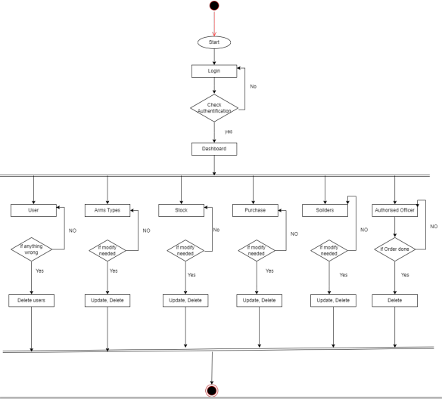

Fig 6.1: Activity Diagram for Admin

##### Activity Diagram for Commander

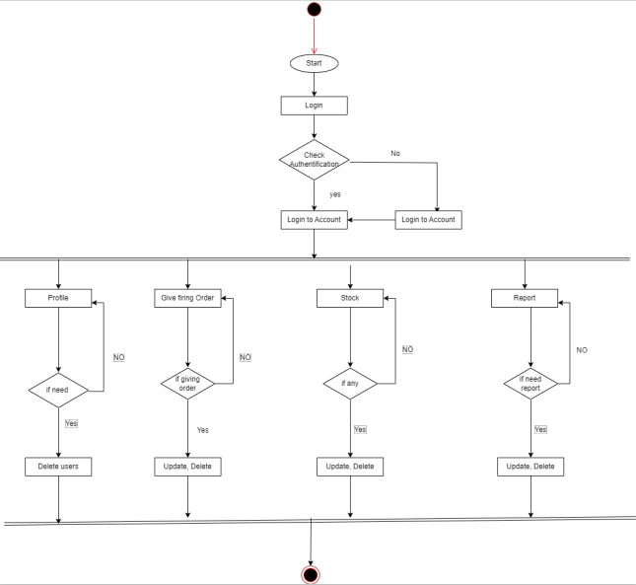

Fig 6.2: Activity Diagram for Commander

##### Activity Diagram for Duty Officer

##### 

##### 

Fig 6.3: Activity Diagram for Duty Officer

##### Data Flow Diagram

* + 1. **Context Level DFD**

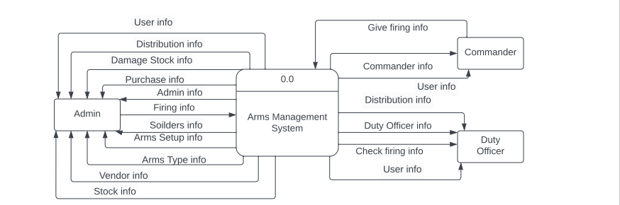

Fig 6.4: Context Level DFD

##### Level 1 DFD

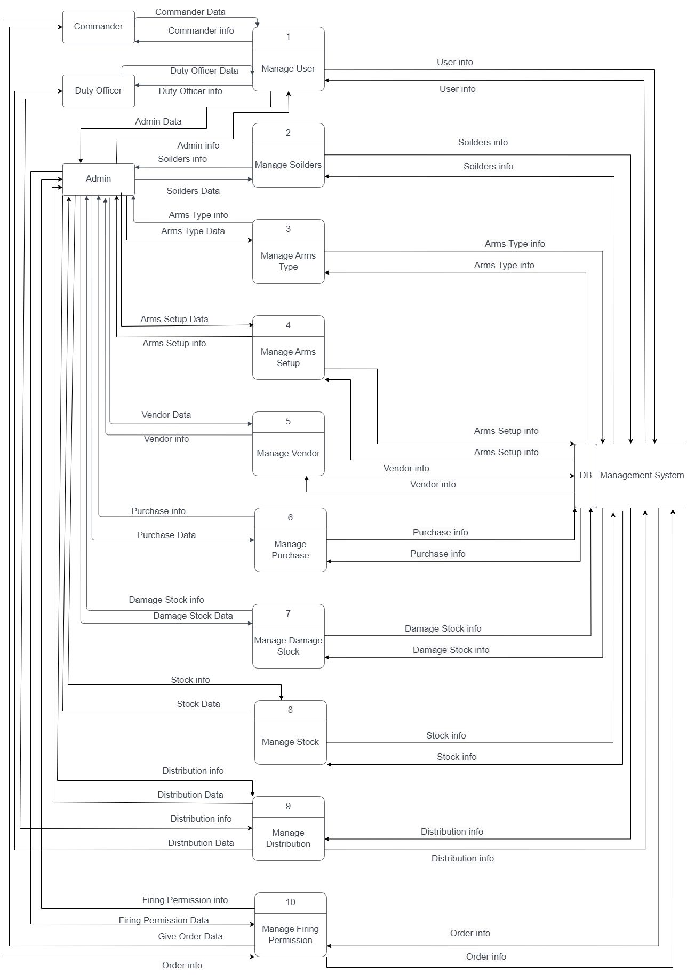

Fig 6.5: Level 1 DFD

##### Level 2 DFD Process 1(Manage User)

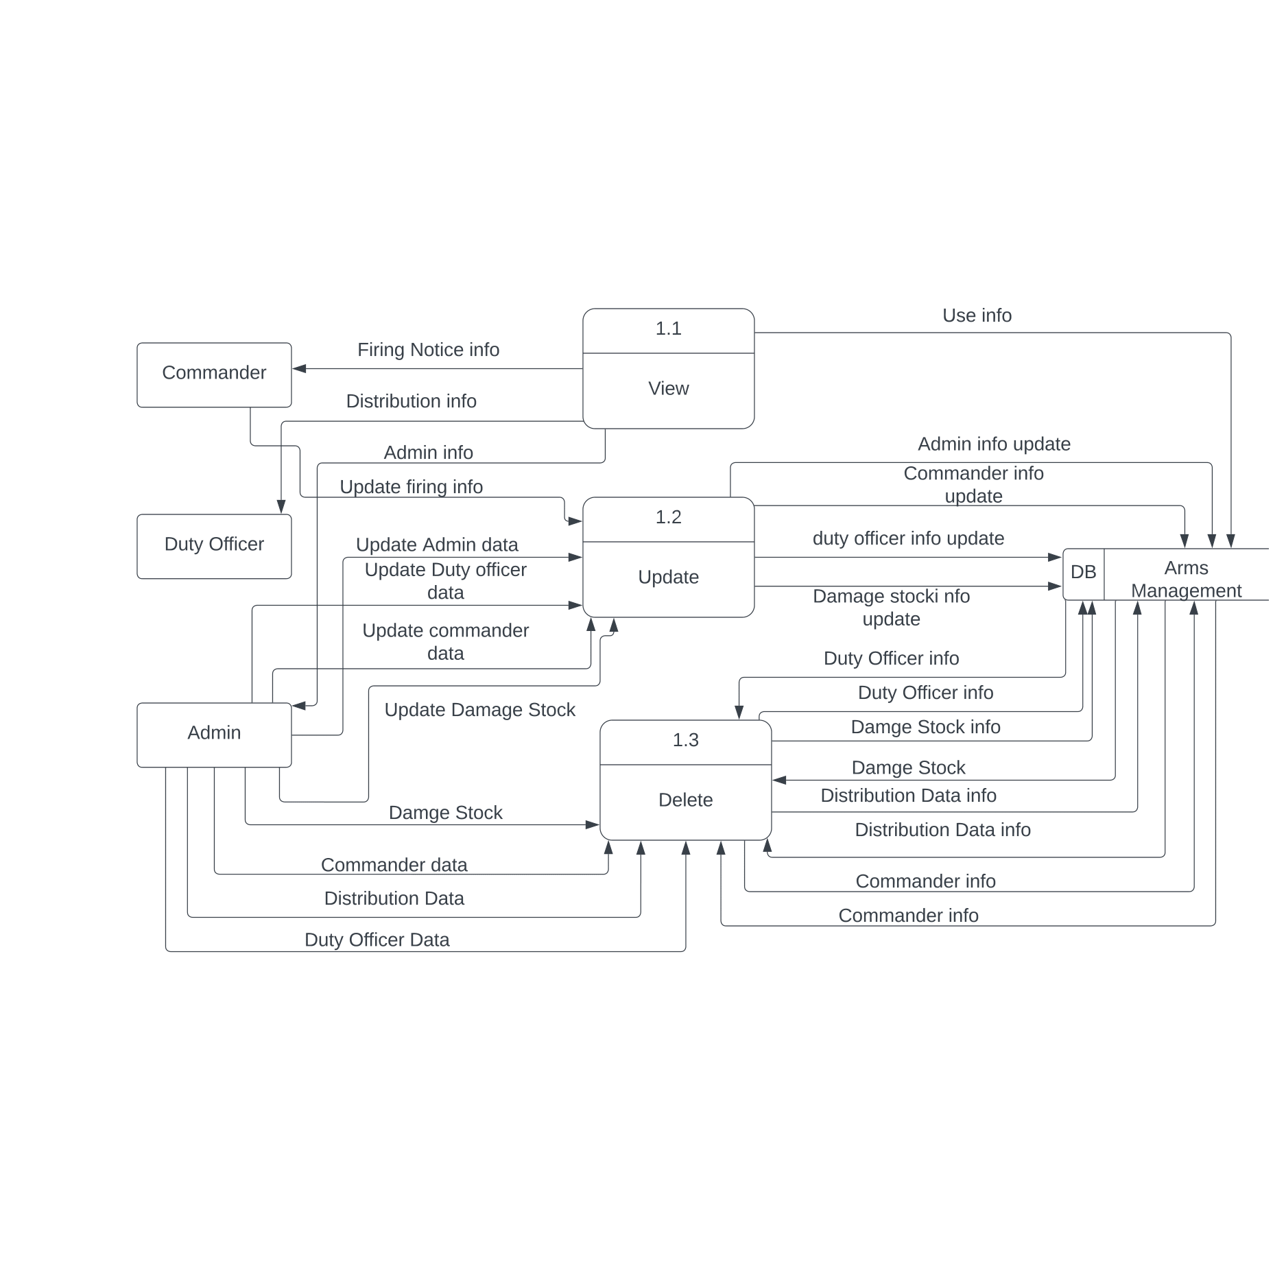

Fig 6.6: Level 2 DFD Process 1 (Manage User)

##### Level 2 DFD Process 2(Arms Types)

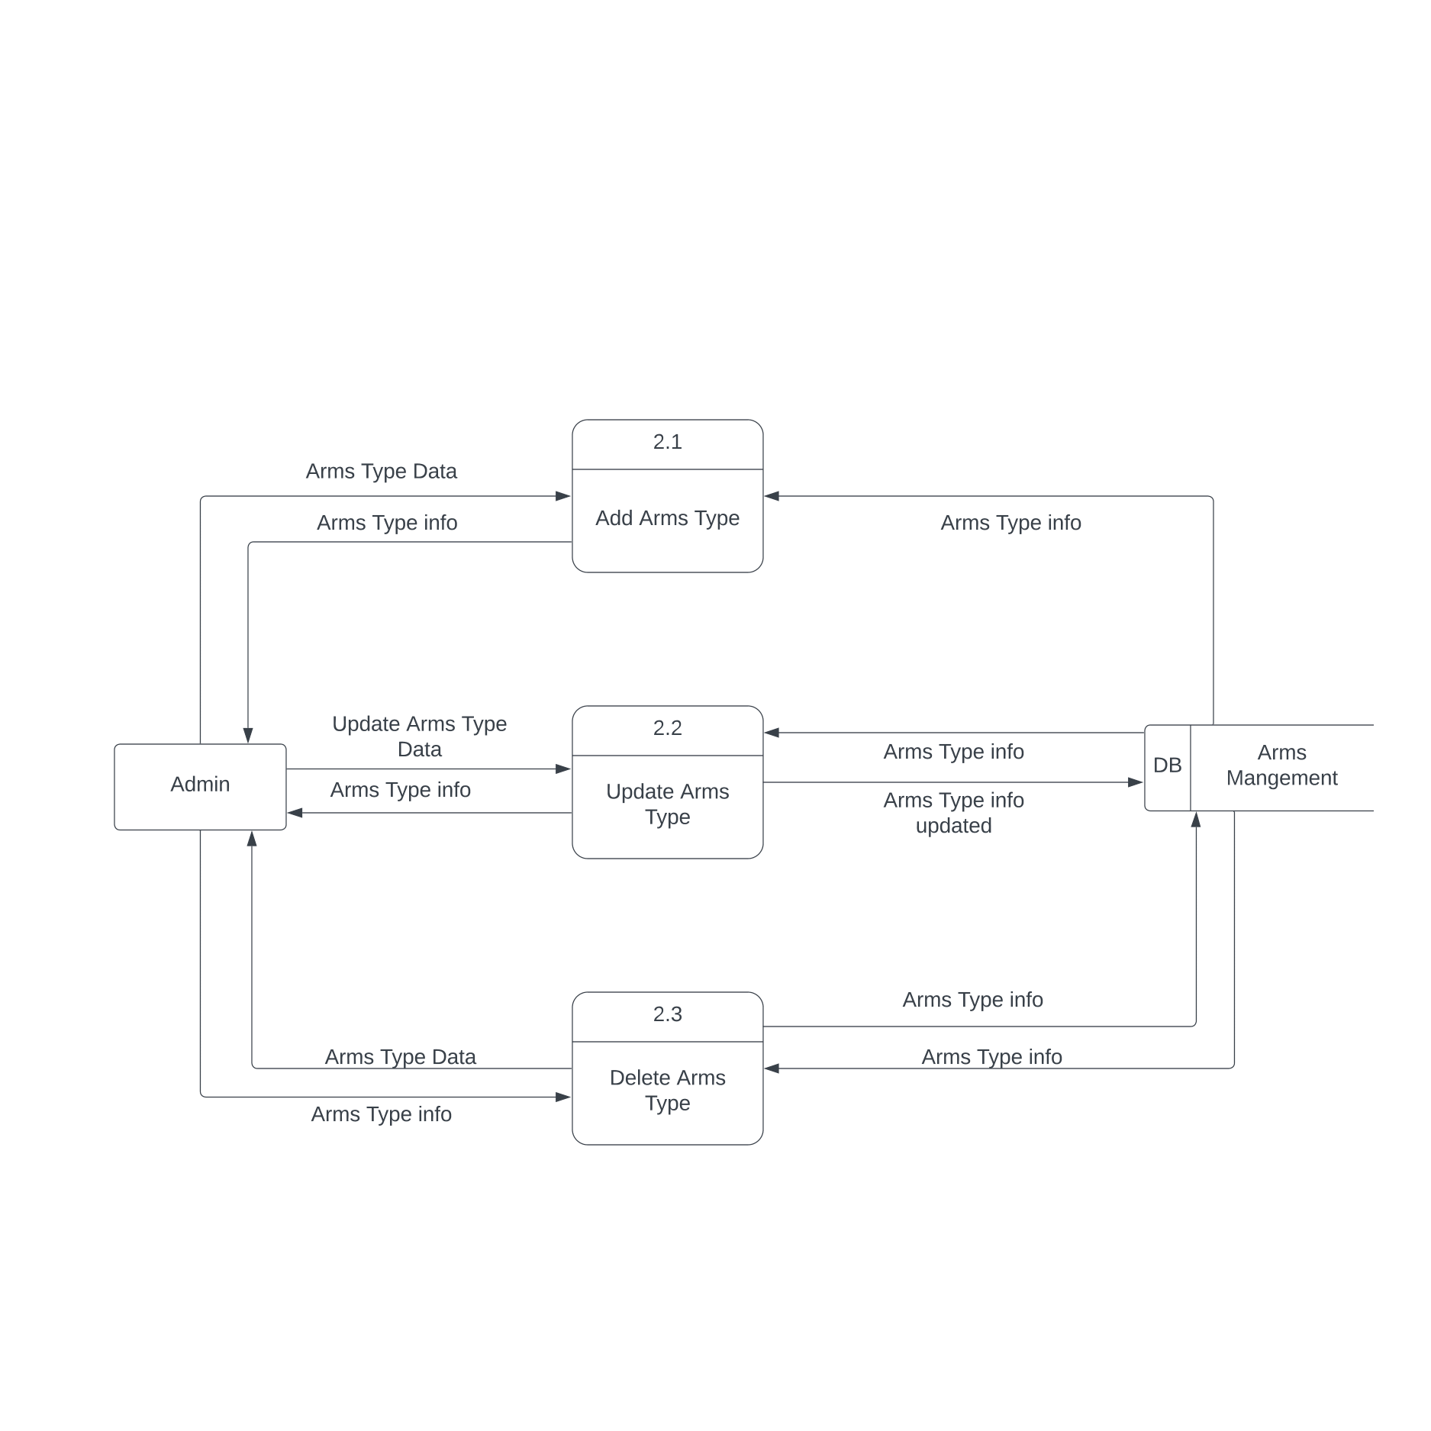

Fig 6.7: Level 2 DFD Process 2 (Arms Types)

##### Level 2 DFD Process 3 (Arms Setup)

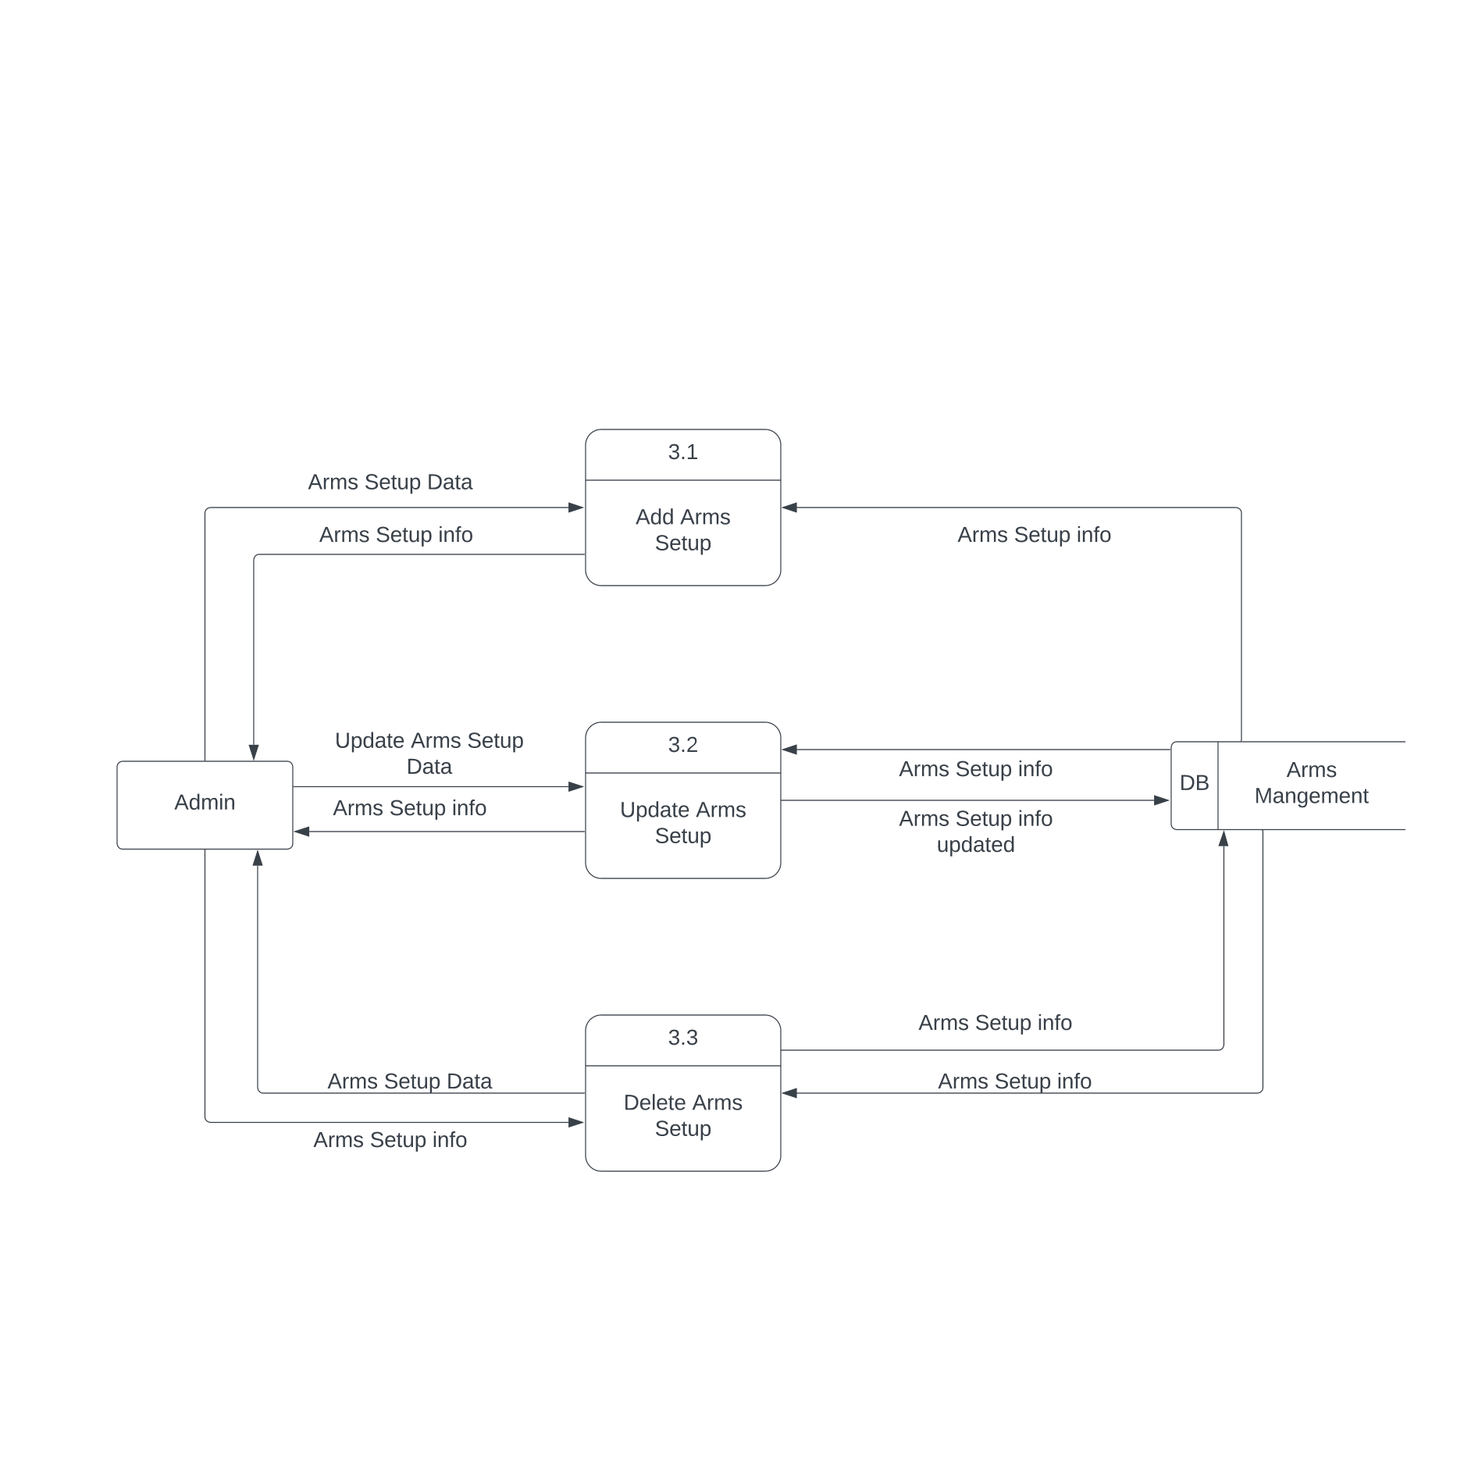

Fig 6.8: Level 2 DFD Process 3 (Arms Setup)

##### Level 2 DFD Process 4 (Vendor)

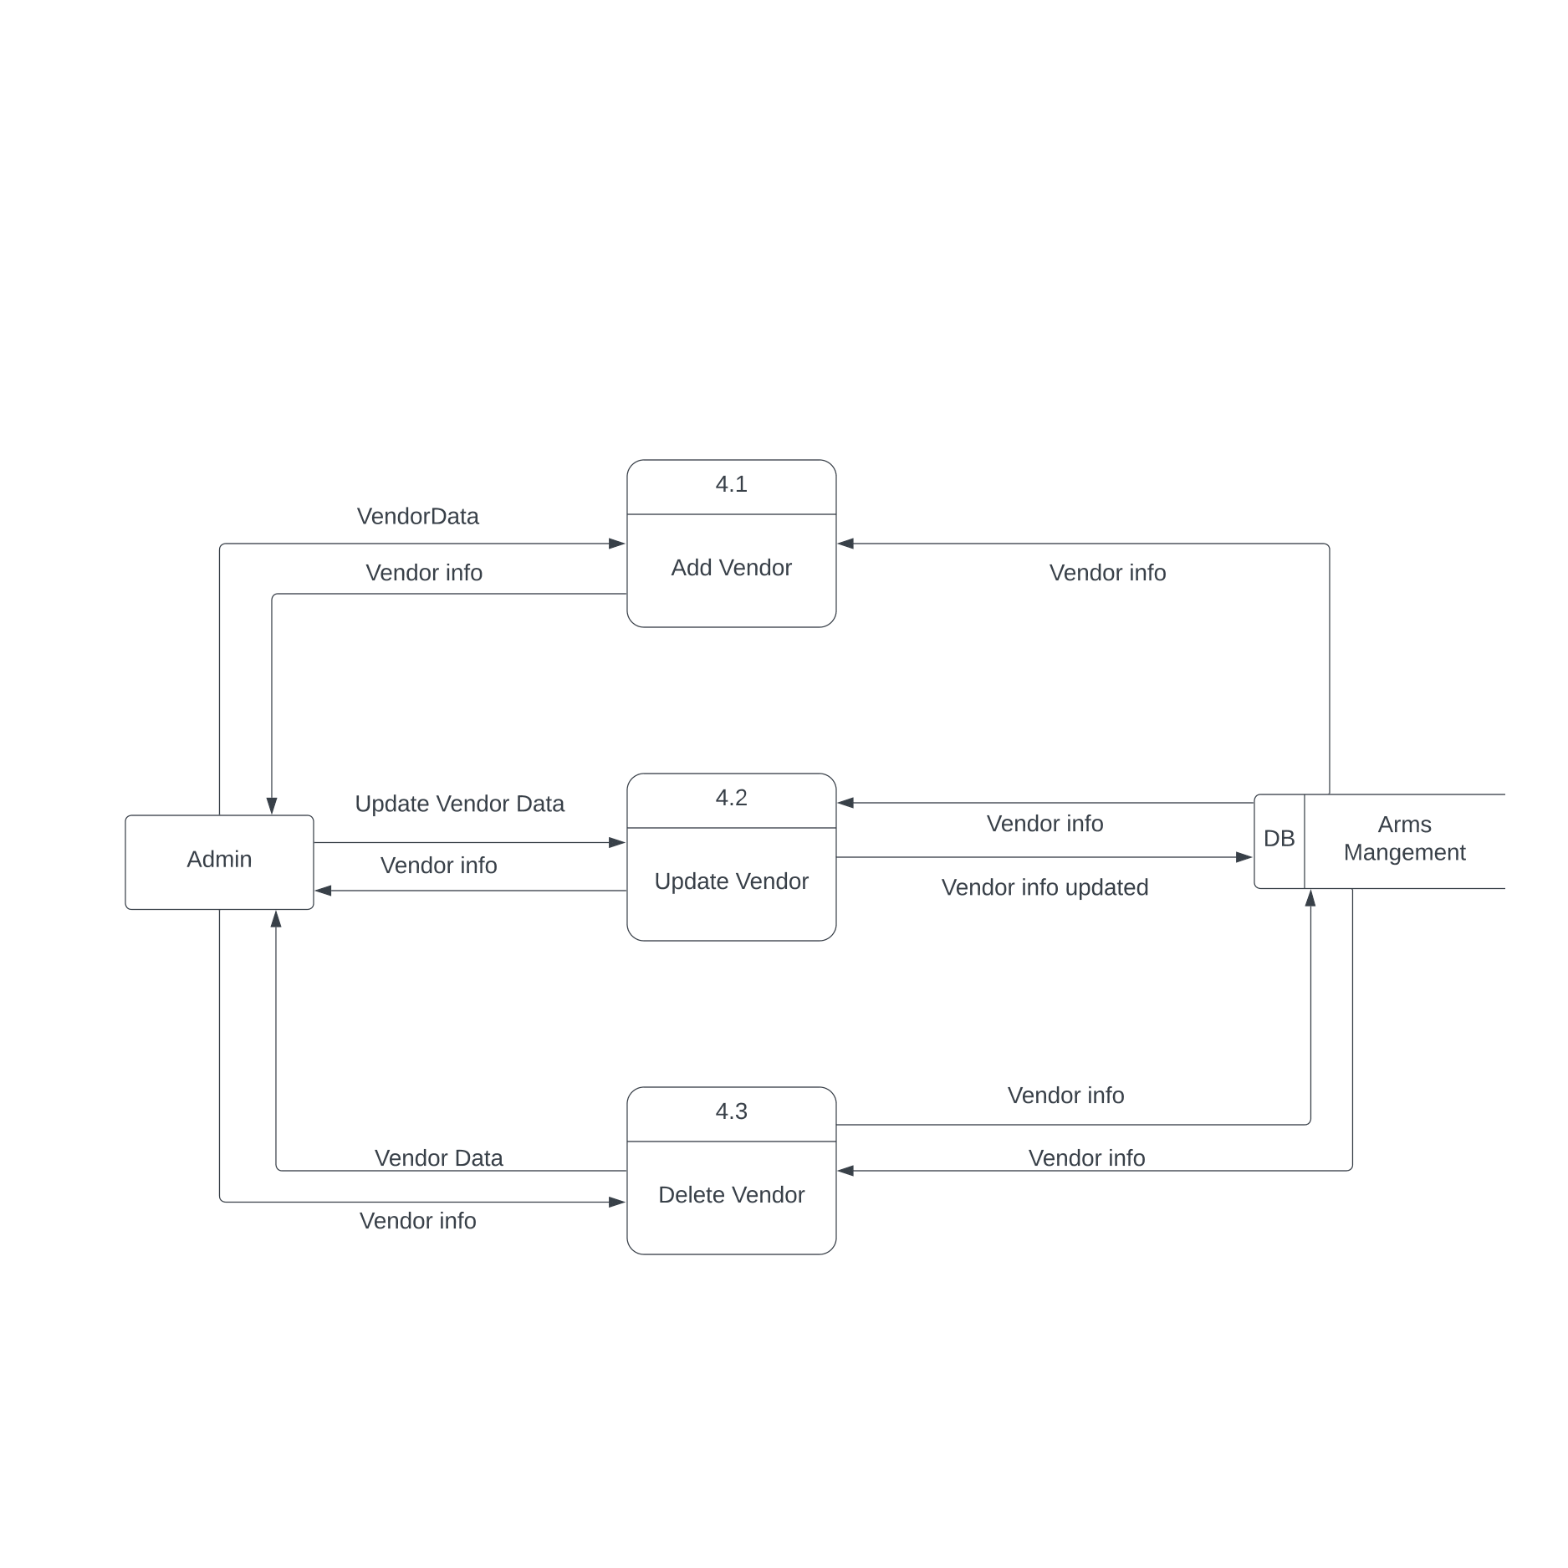

Fig 6.9: Level 2 DFD Process 4 (Vendor)

##### Level 2 DFD Process 5 (Purchase)

##### 

Fig 6.10: Level 2 DFD Process 5 (Purchase)

##### Level 2 DFD Process 6(Stock)

##### 

Fig 6.11: Level 2 DFD Process 6 (Stock)

##### Level 2 DFD Process 7 (Damage Stock)

##### 

Fig 6.12: Level 2 DFD Process 7 (Damage Stock)

##### Level 2 DFD Process 8 (Generate Report)

##### 

Fig 6.13: Level 2 DFD Process 8 (Generate report)

##### Level 2 DFD Process 9 (Generate Report)

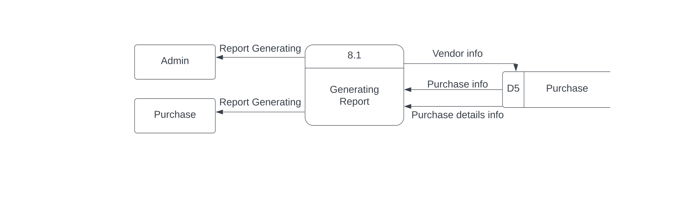

Fig 6.14: Level 2 DFD Process 9 (Generate report)

##### Entity Relationship Diagram

##### 

Figure 6.15: Entity Relationship Diagram

## Chapter 07 Designing



##### Database Schema Design

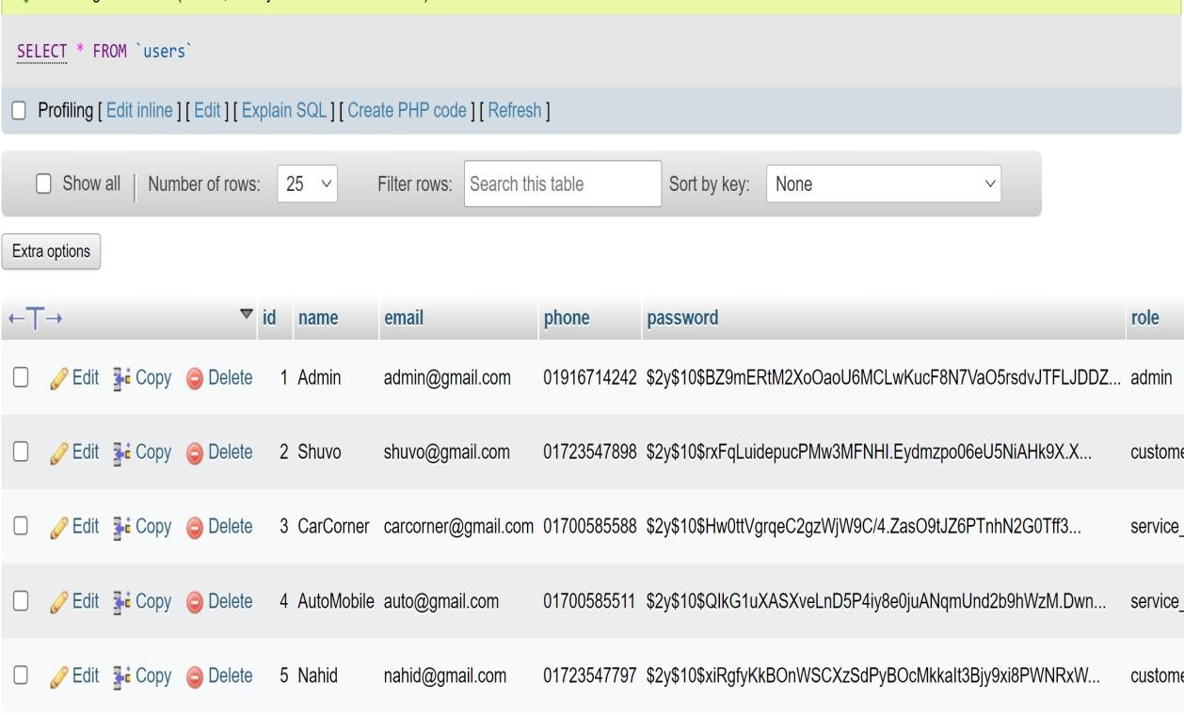

Figure 7.1: User Table

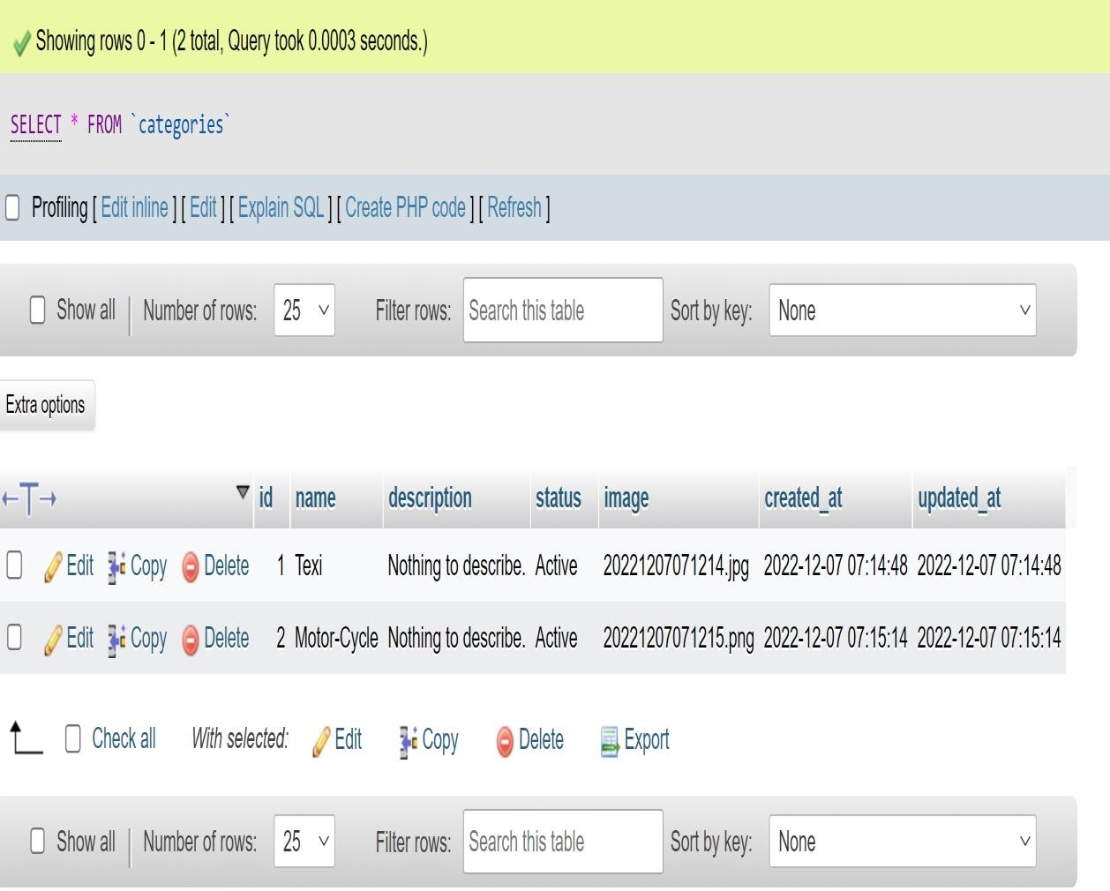

Figure 7.2: Category Table

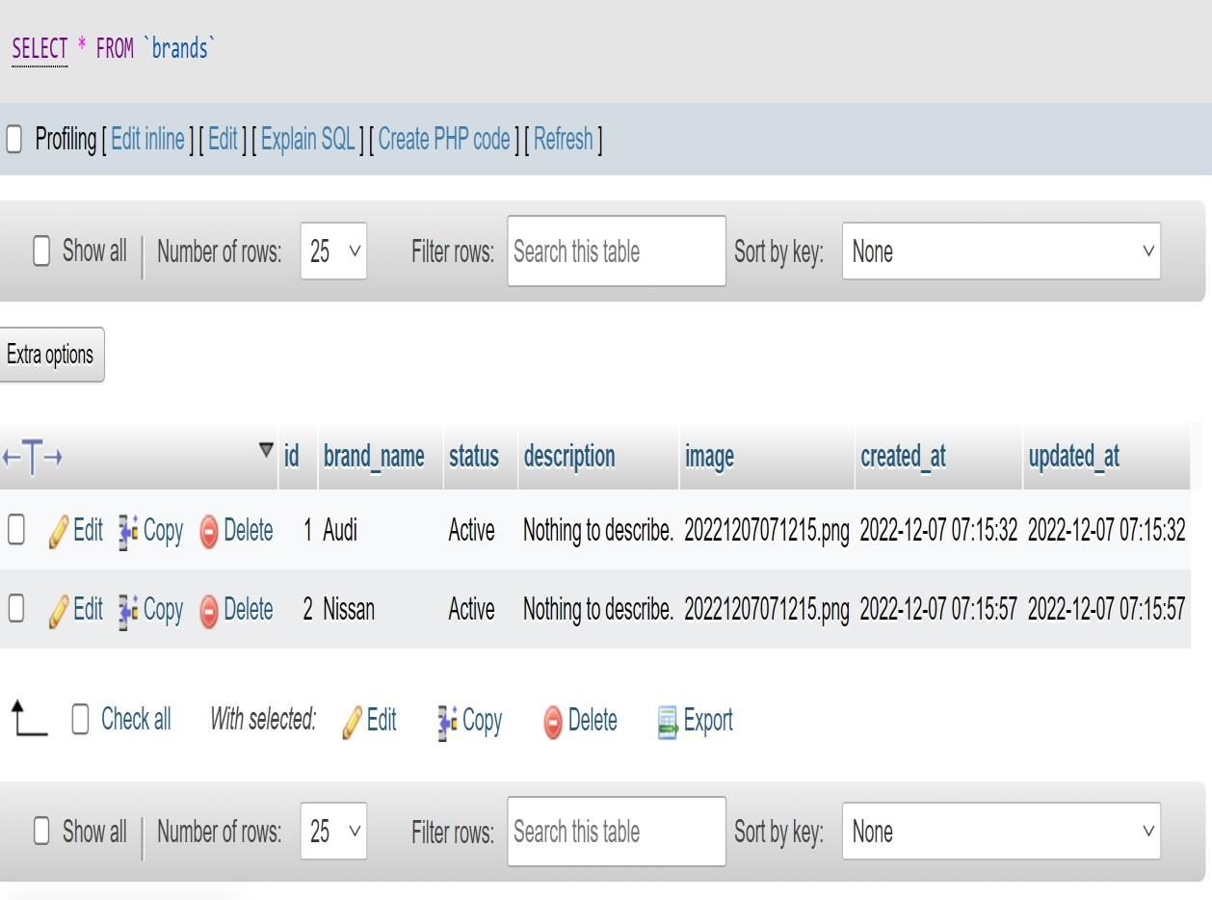

Figure 7.3: Brand Table

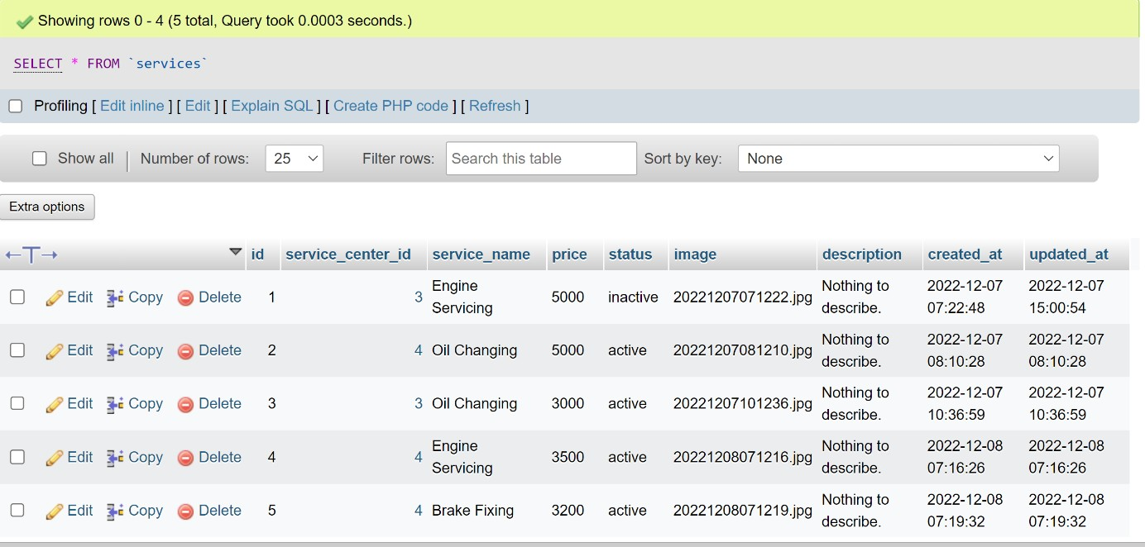

Figure 7.4: Service Table

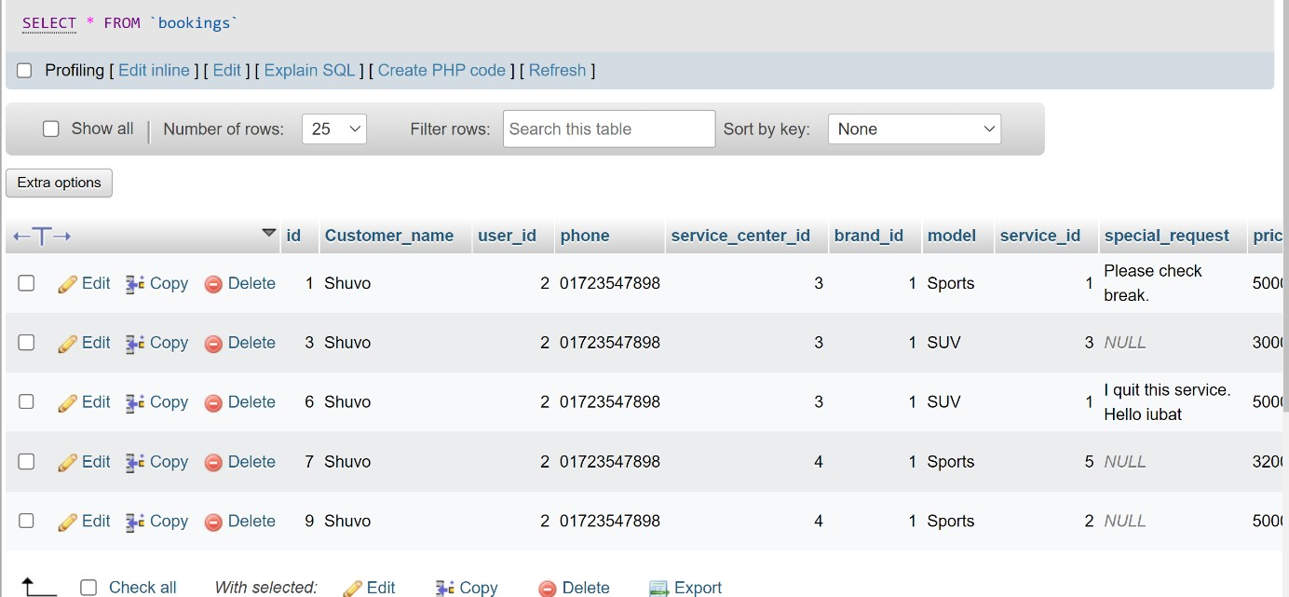

Figure 7.5: Booking Table

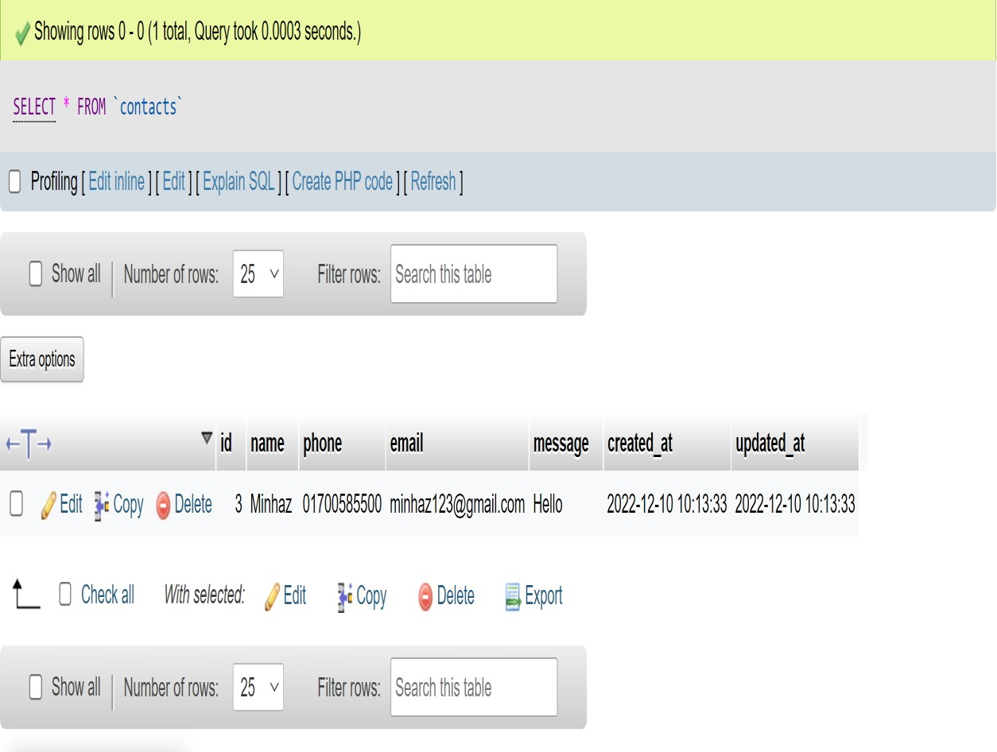

Figure 7.6: Contact Table

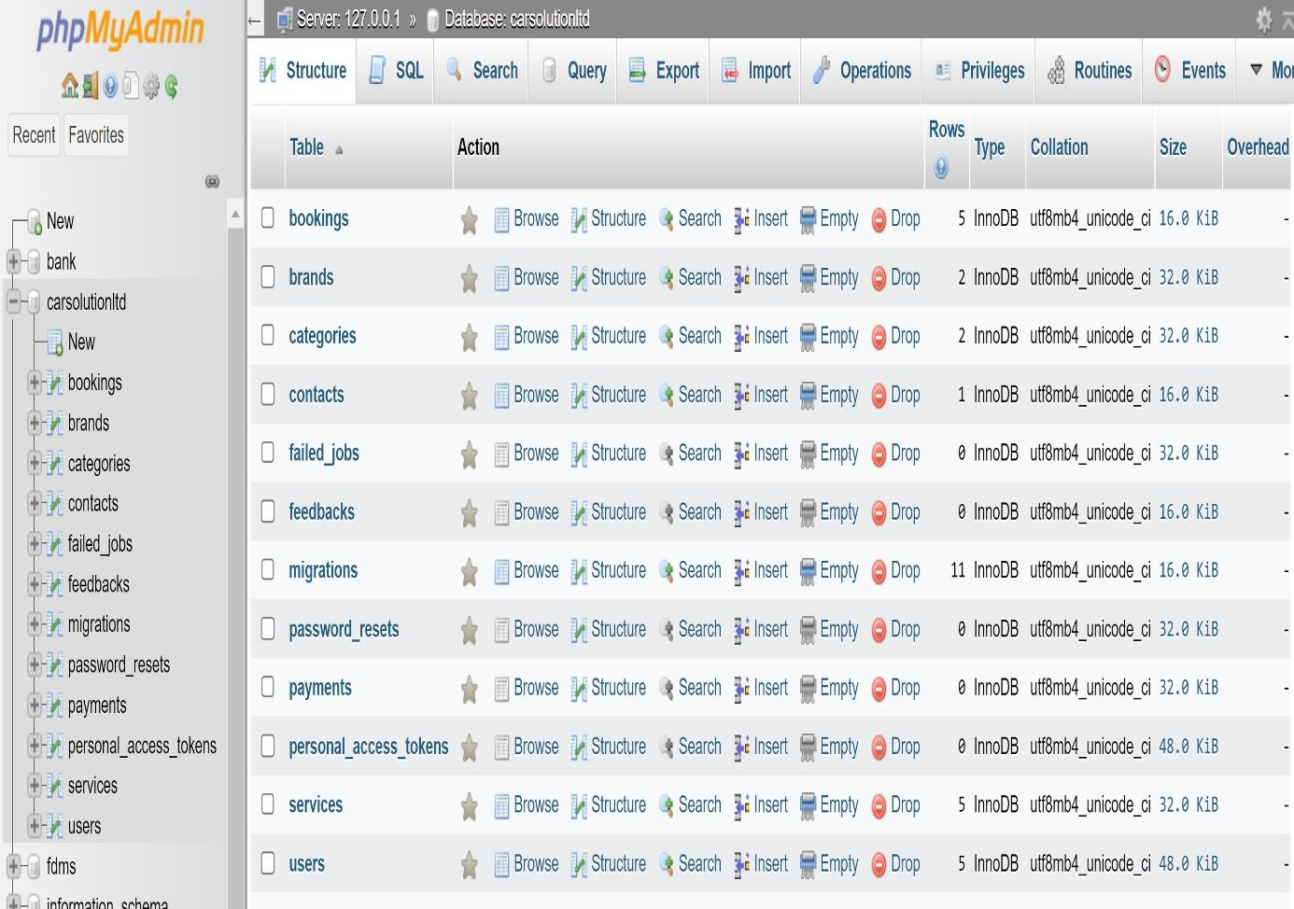

Figure 7.7: Full Database Table

58

##### Interface Design

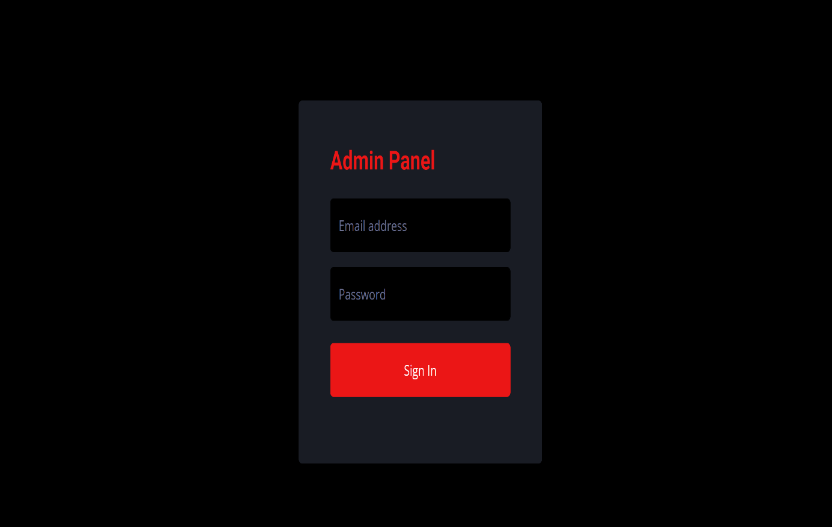

Figure 7.8: Admin Login Page

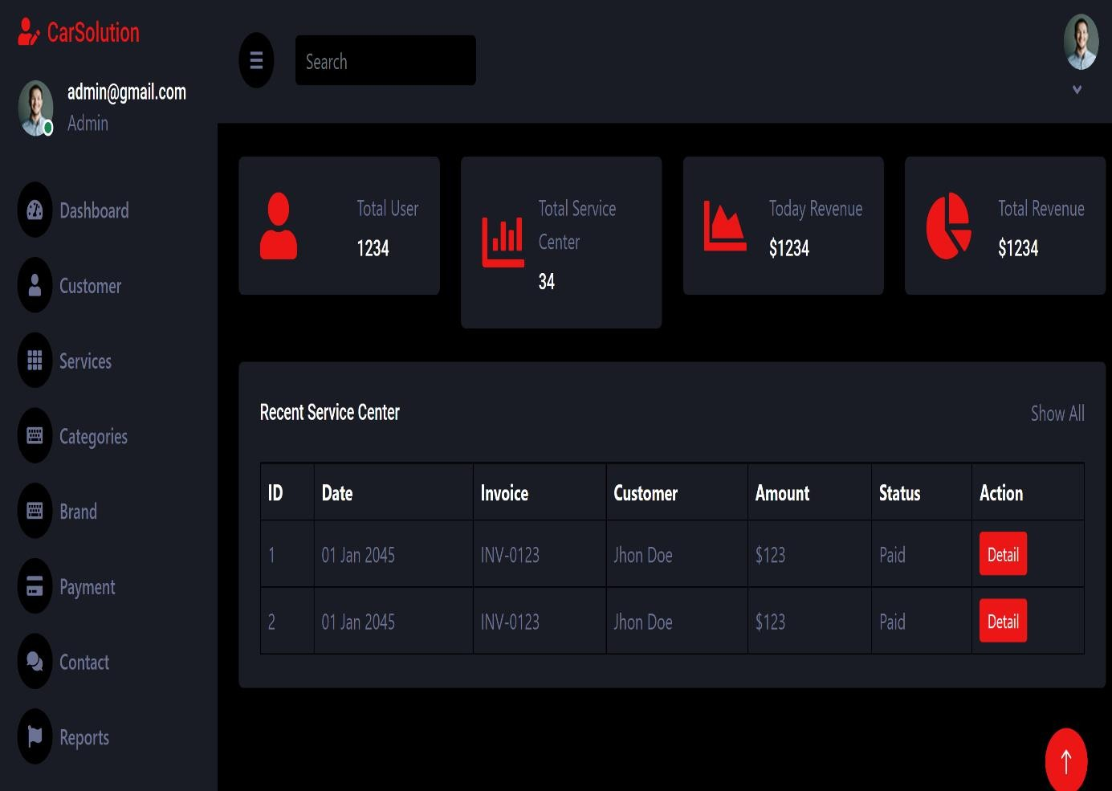

Figure 7.9: Dashboard Page

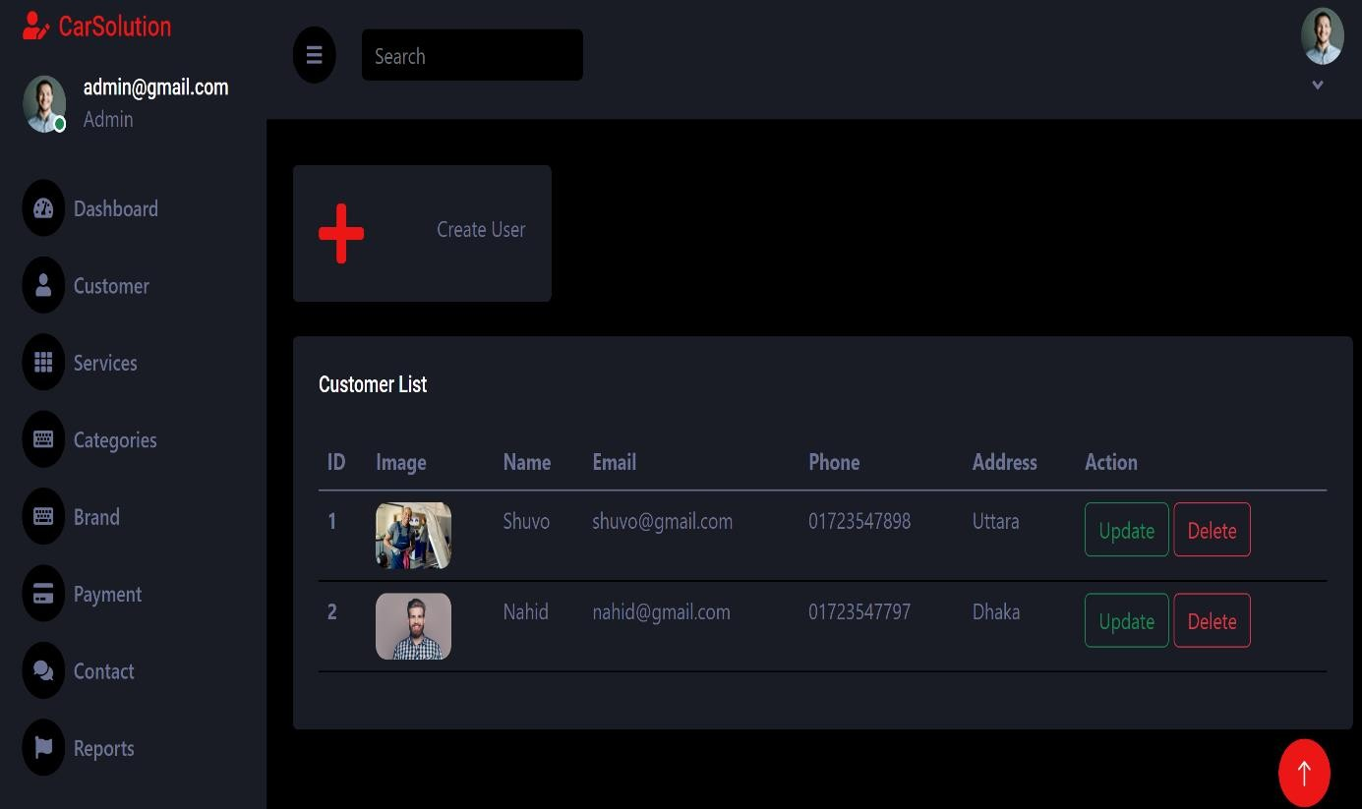

Figure 7.10: Add User Page

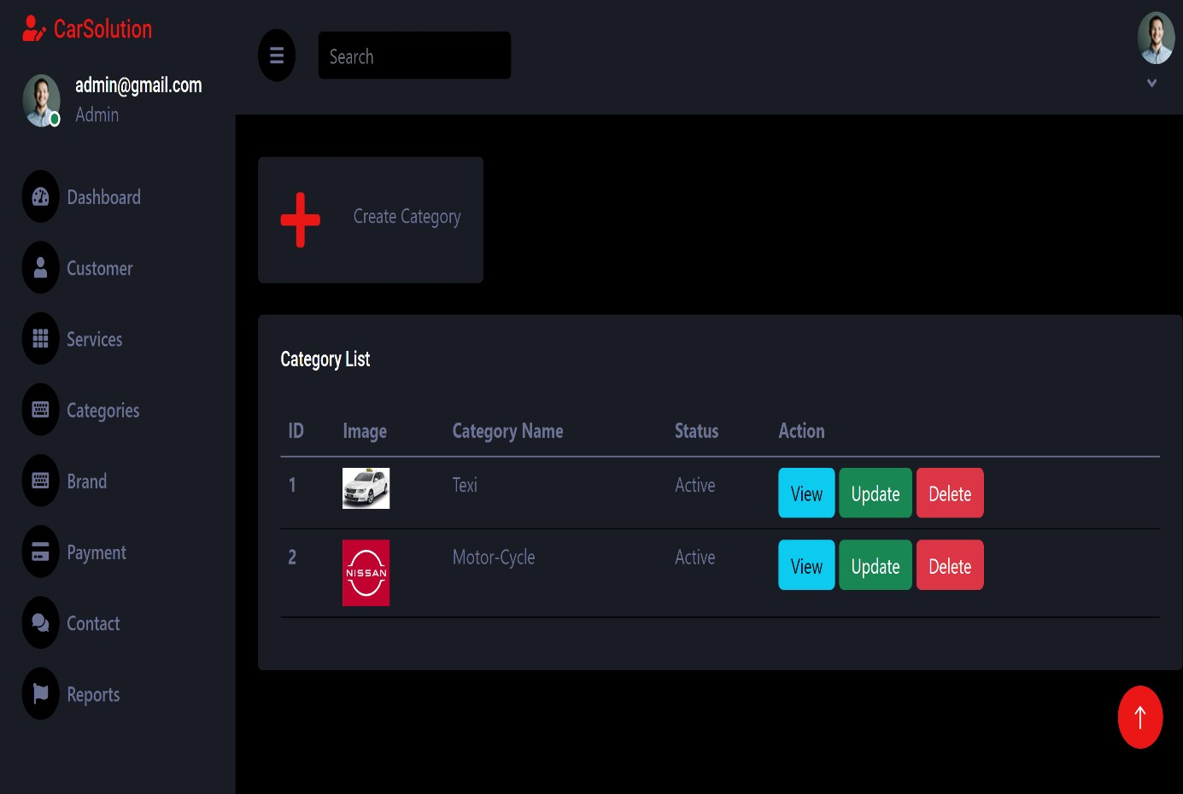

Figure 7.11: Manage Category Page

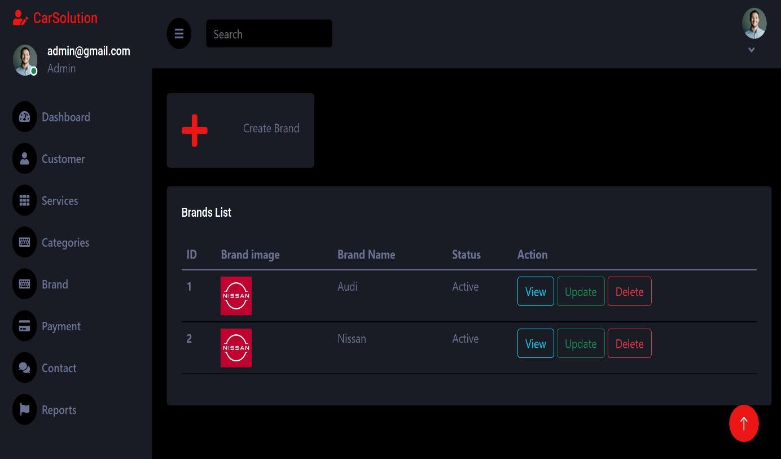

Figure 7.12: Add Brand Page

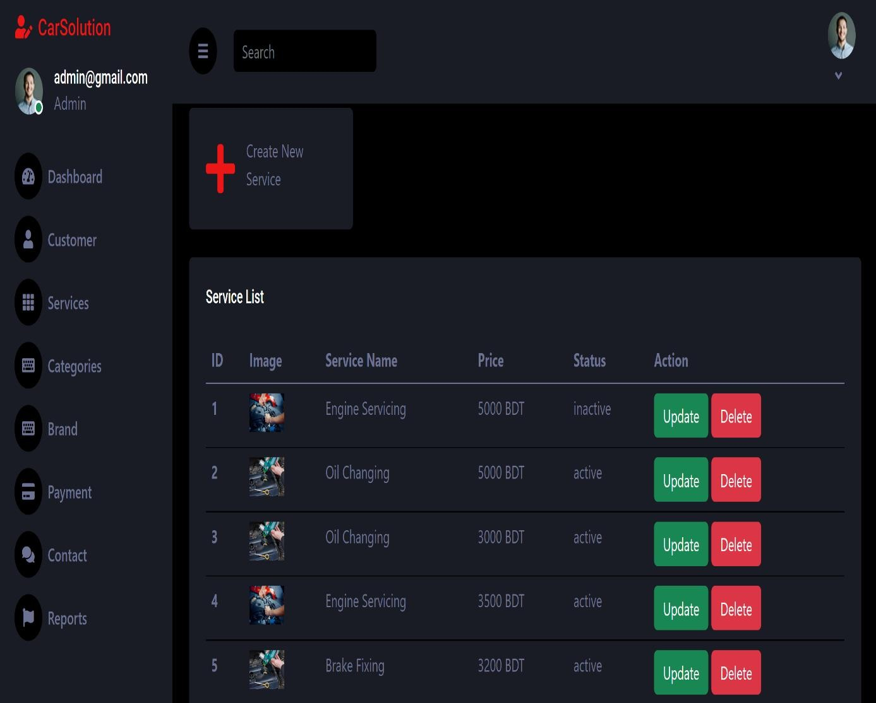

Figure 7.13: Manage Service Page

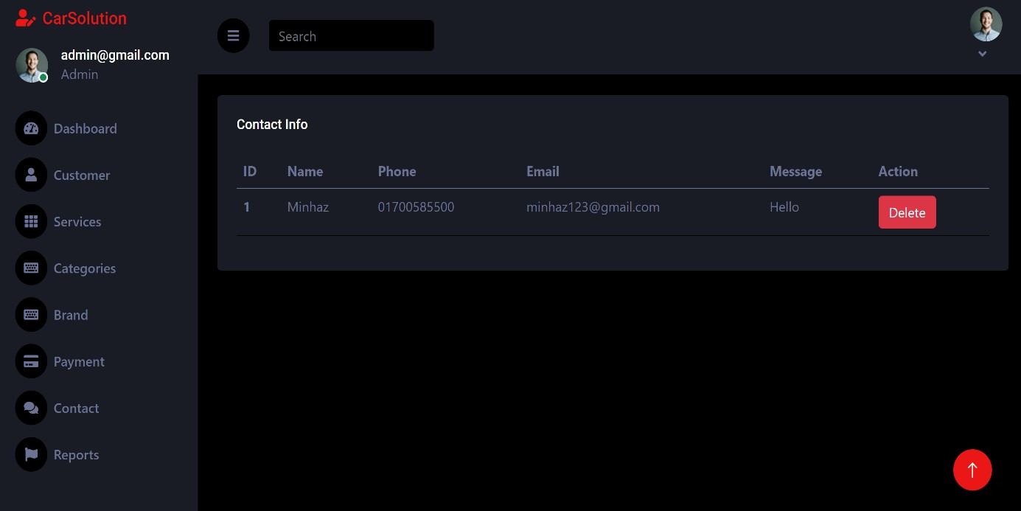

Figure 7.14: Contact info Page

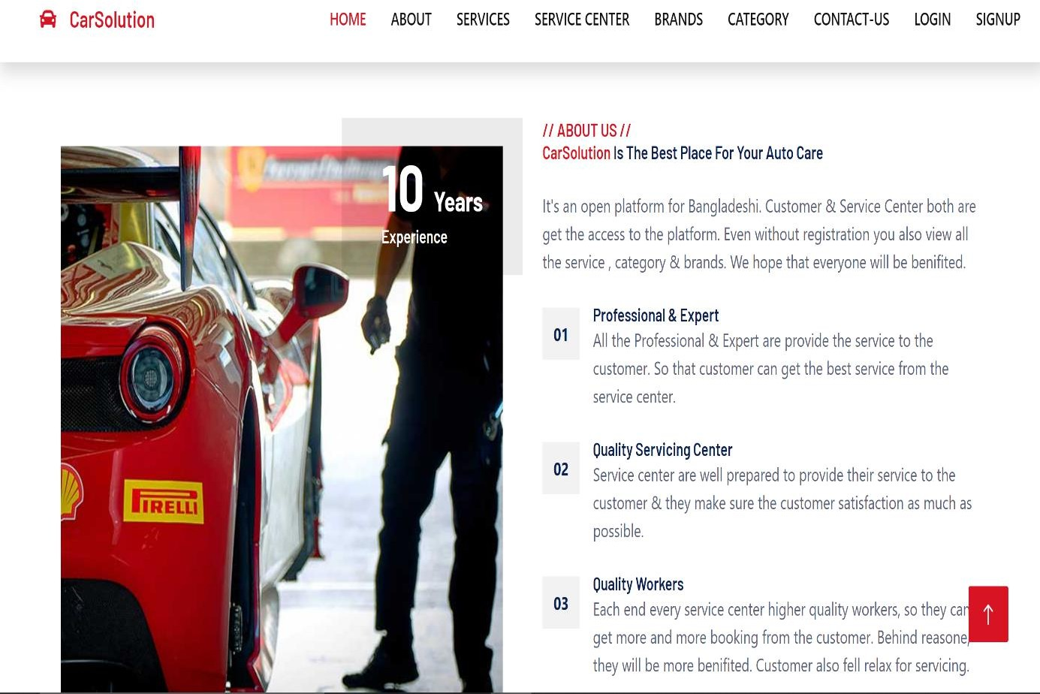

Figure 7.15: About Page

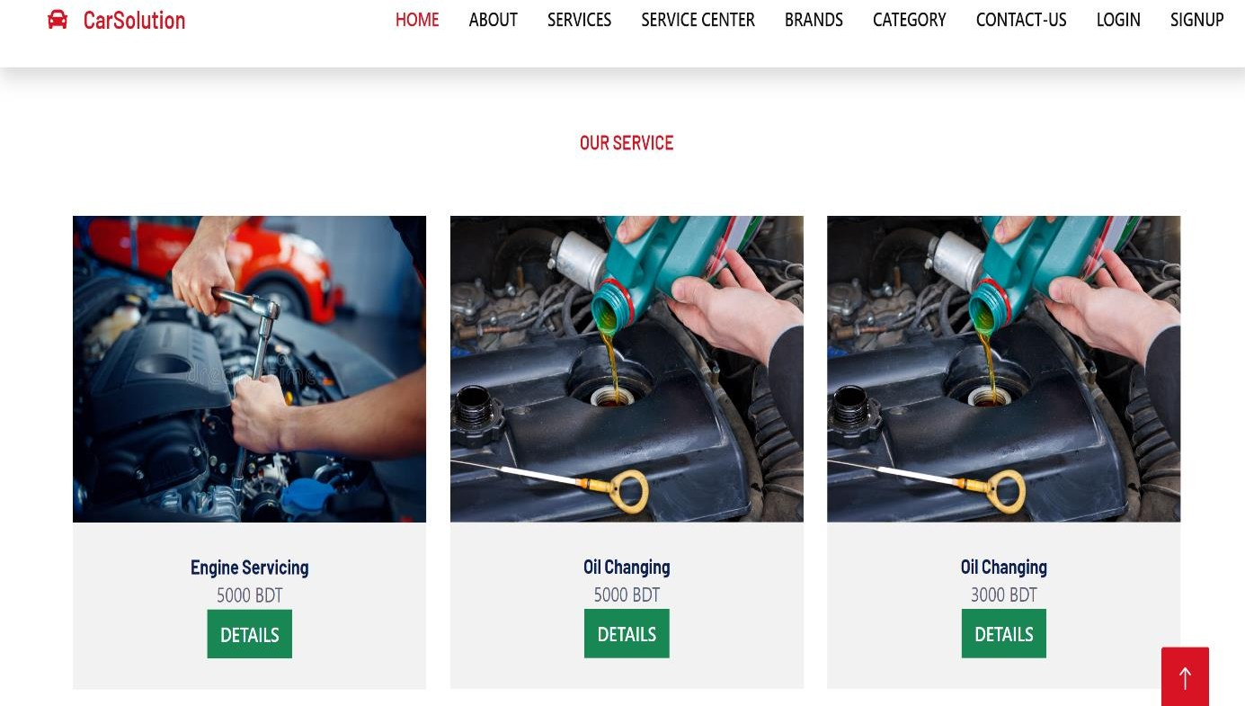

Figure 7.16: Service Page

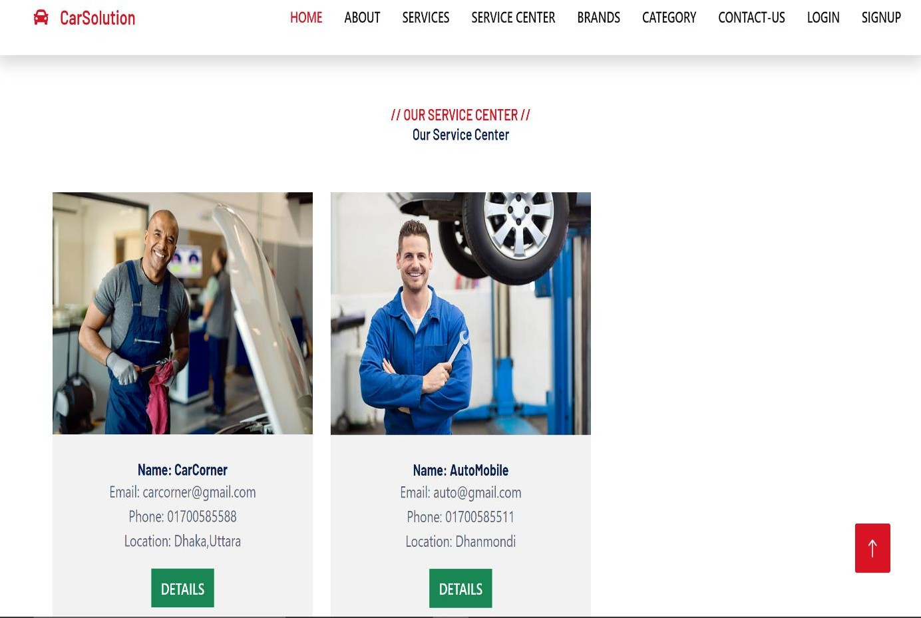

Figure 7.17: Service Center Page

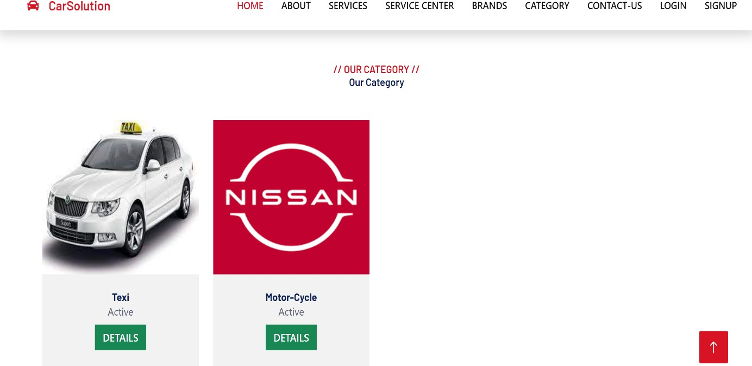

Figure 7.18: Category Page

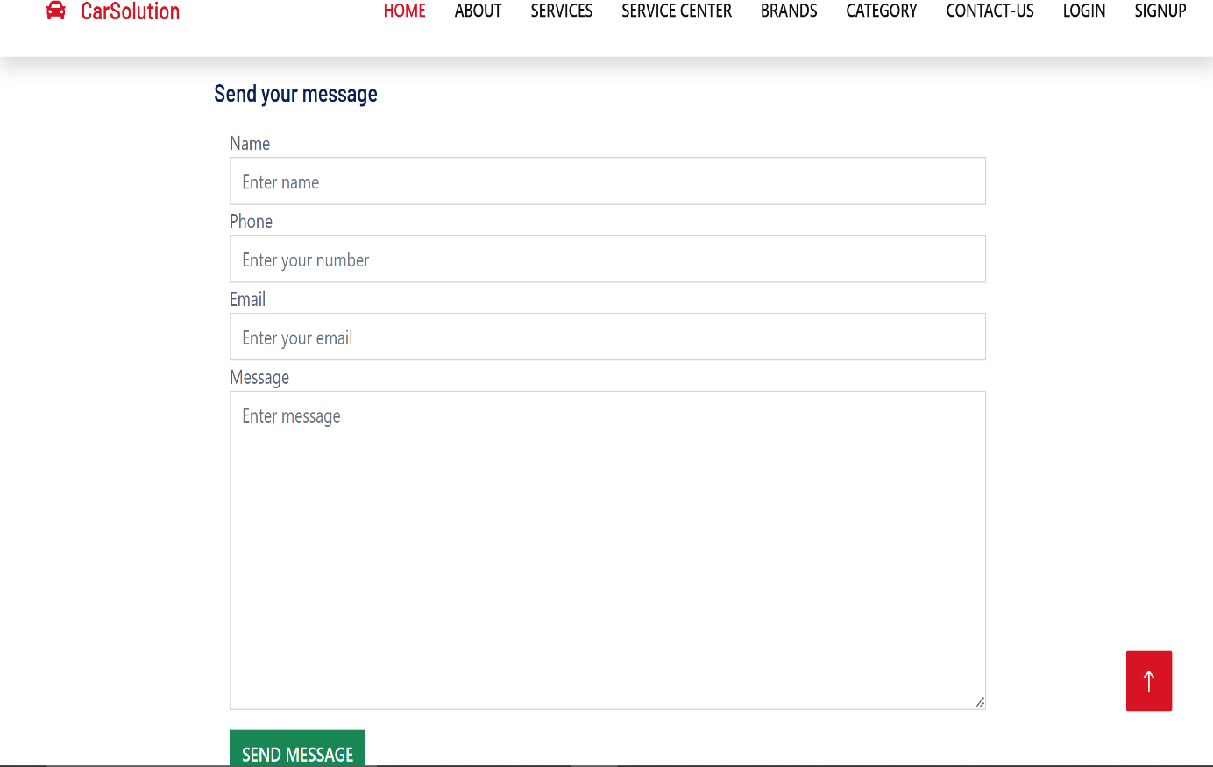

Figure 7.19: Contact-US Page

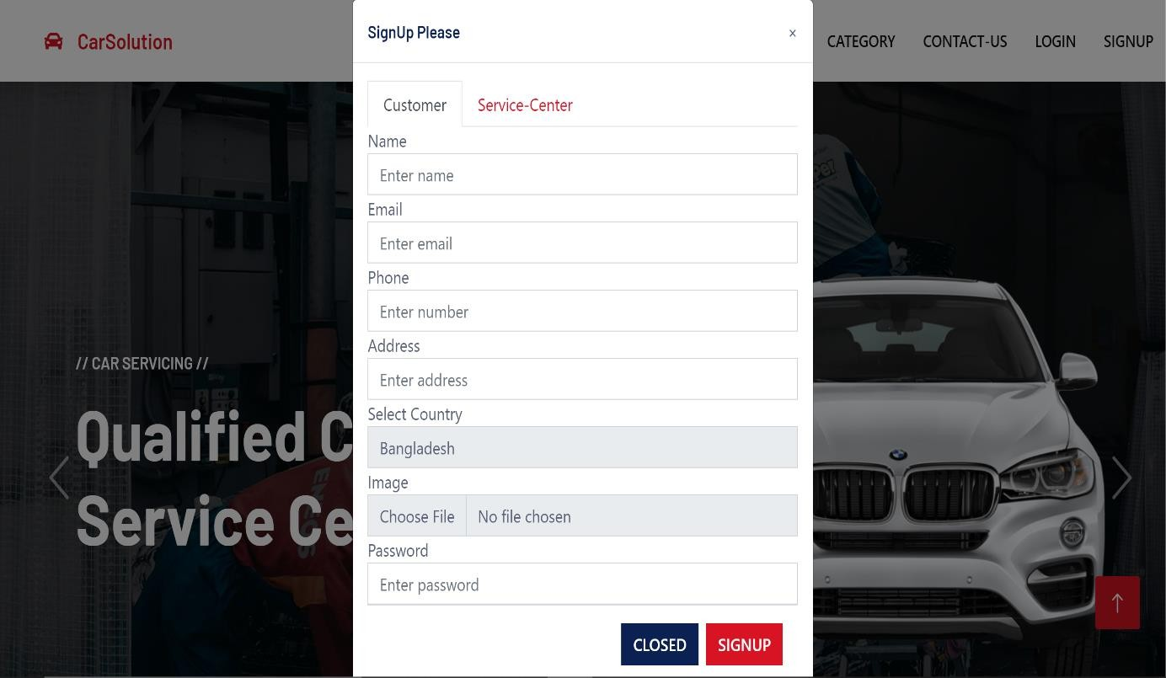

Figure 7.20: User Sign Up Page

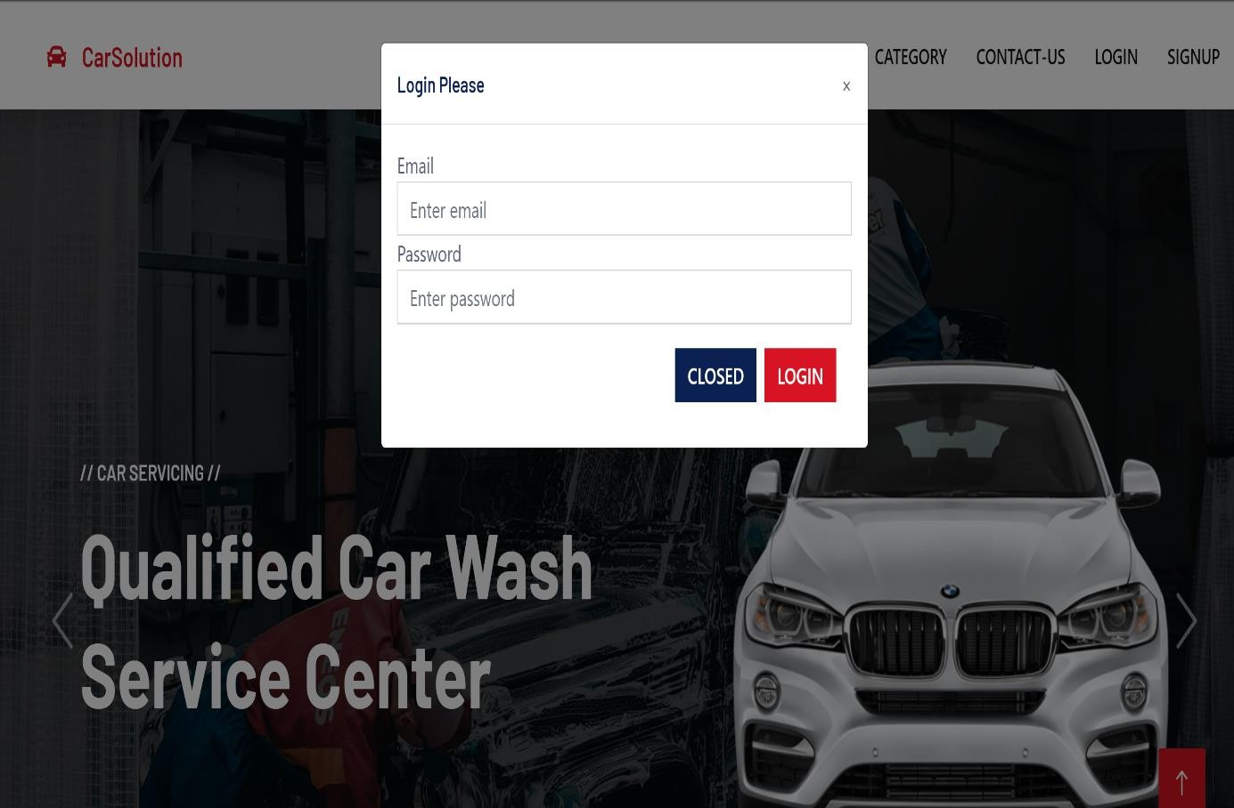

Figure 7.21: User Login Page

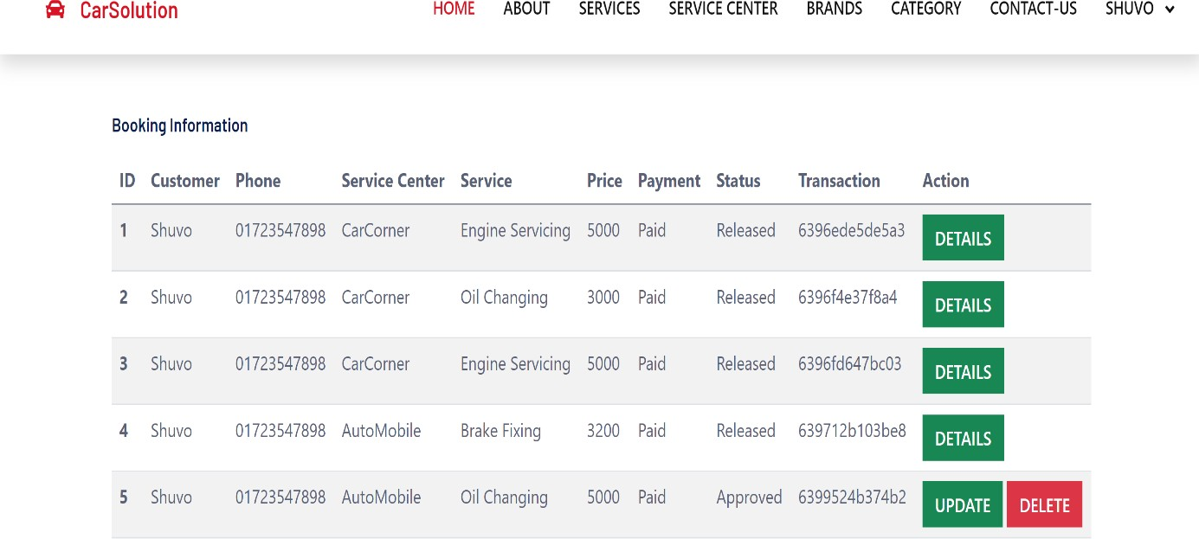

Figure 7.22: Customer Booking Info Page

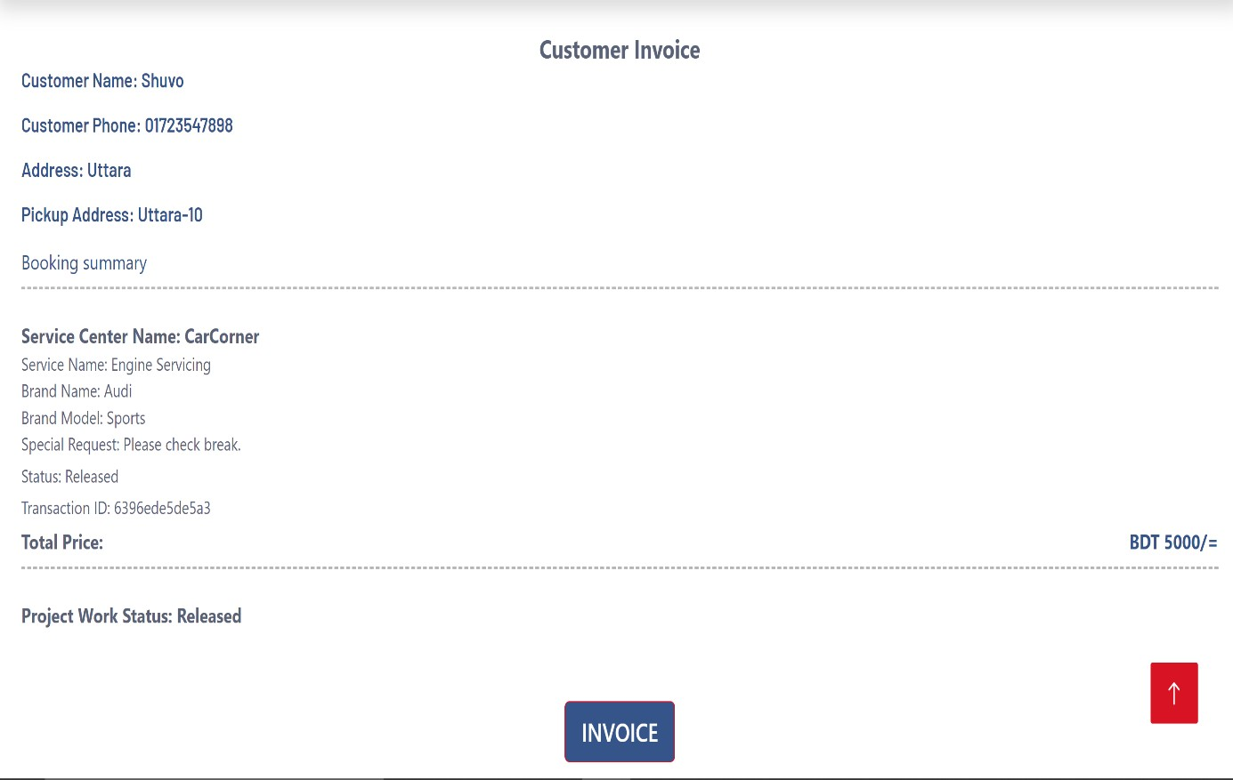

Figure 7.23: Customer Invoice Page

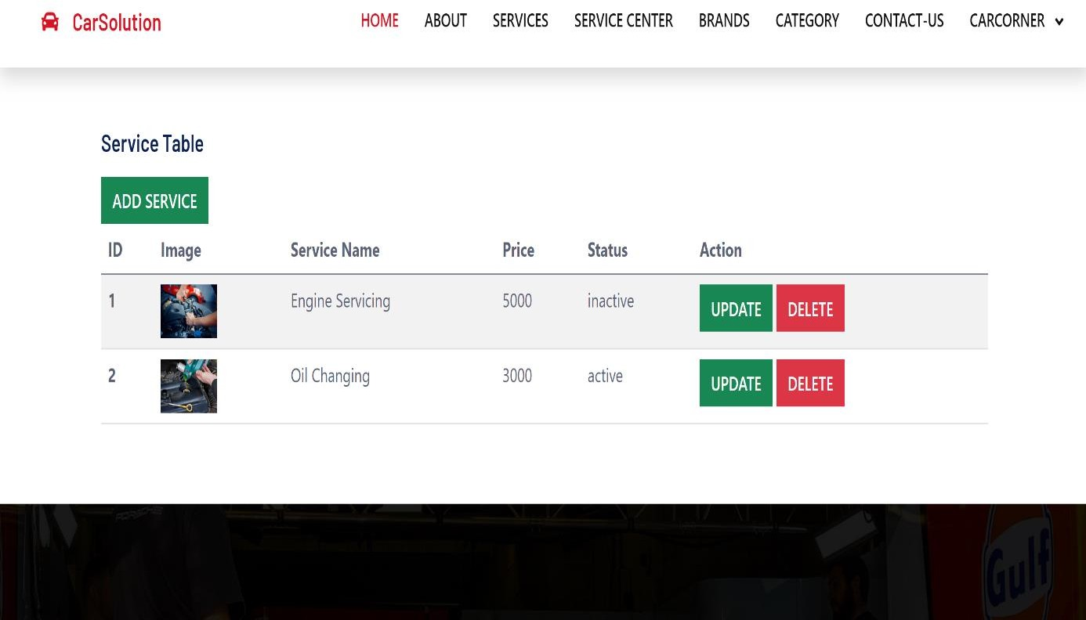

Figure 7.24: Service Add Page

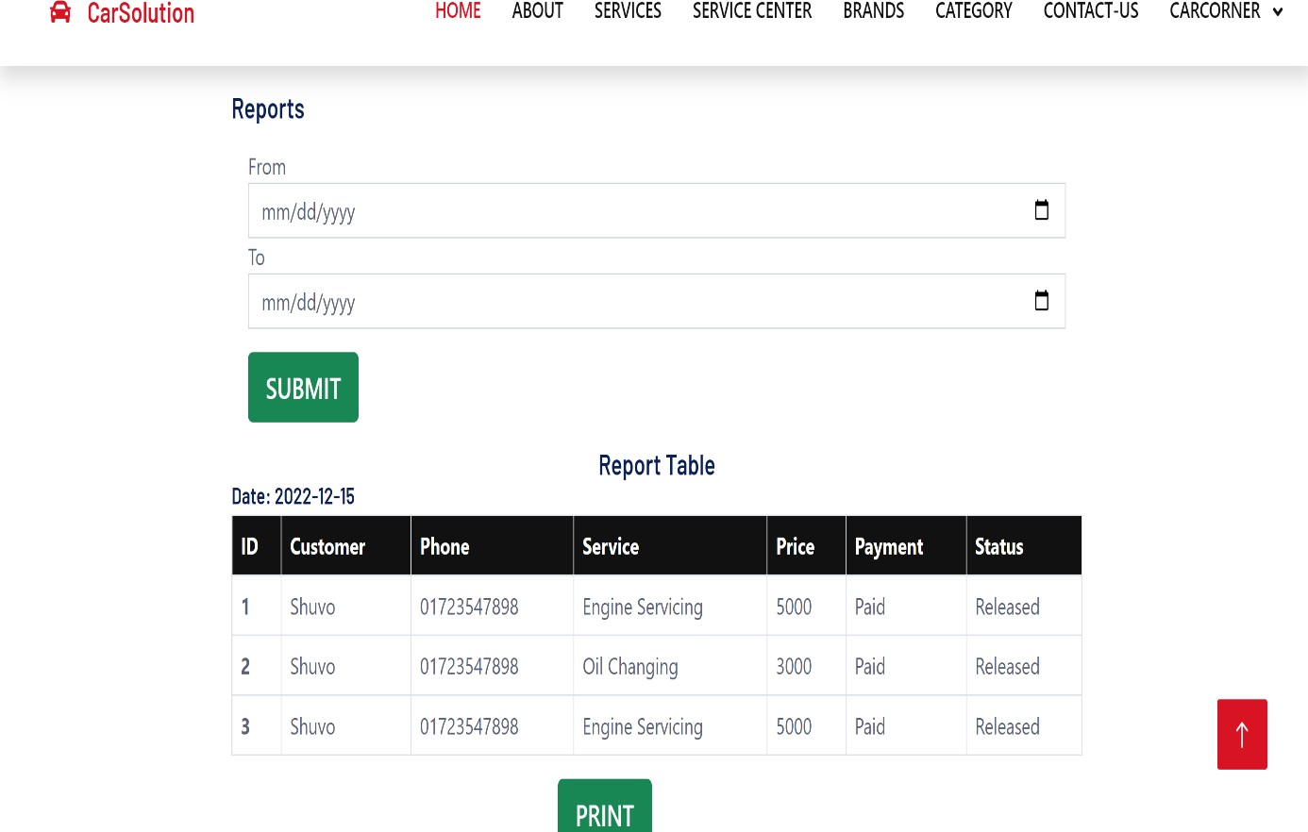

Figure 7.25: Service Center Report Page

## Chapter 08 Quality Assurance

##### System Testing

Testing is the process of examining a system or its components with the goal of determining if they meet the requirements. Simply put, testing is the process of running a system to find any gaps, faults, or missing requirements that are not met by the real requirements.

Knowing a particular feature for which the software was designed allows you to run tests that fully demonstrate each feature while at the same time debugging each feature. This approach is known as black-box testing.

With the internal working software in hand, tests may be run to confirm that internal activities are carried out as expected and that all internal components have been appropriately exercised. White-box testing is the term for this method.

##### White Box Testing Results Table Test Title: User Registration Table

|  |  |  |  |  |
| --- | --- | --- | --- | --- |
| **Steps** | **Test Data** | **Expectation** | **Actual Result** | **Status** |
| Input New user Information | New user | New user will be Added | New User in User Table | PASS |
| Redirect to Admin Dashboard | Dashboard | Login page to Dashboard | Redirected to Dashboard after | PASS |

**Test Title: Login Table**

|  |  |  |  |  |
| --- | --- | --- | --- | --- |
| **Steps** | **Test Data** | **Expectation** | **Actual Result** | **Status** |
| Login with proper credentials | Email and Password | Respective Dashboard according to user- type | Redirected to respective dashboard according to user-type | PASS |

**Test Title: Profile Management Table**

|  |  |  |  |  |
| --- | --- | --- | --- | --- |
| **Steps** | **Test Data** | **Expectation** | **Actual Result** | **Status** |
| Profile Picture  Change | New Image from device | Showphoto | Photo Visible | PASS |
| Change General  Information | Name, Phone, Address | Show Updated Information in My Profile | Information  Updated | PASS |



##### Test Title: Added Contents Table

|  |  |  |  |  |
| --- | --- | --- | --- | --- |
| **Steps** | **Test Data** | **Expectation** | **Actual Result** | **Status** |
| Add brand | Brand | Brand will be added | Brand Added | PASS |
| Add Category | Category | Category Will be Added | Category Added | PASS |
| Add Service | Service | Service will be added | Service Added | PASS |



## Chapter 09 Conclusion

##### Limitation

* + - User have limited access to function
    - Customer can’t add service
    - Customer can’t manage reports
    - Service Center can’t manage Category
    - Service Center can’t manage Brand

##### Future Work

* + - Login or Signup through google account or social media account.
    - Send notification for customer booking.
    - Email verification also available.
    - A mobile app will be developed.
    - Service center show on google map direction.

##### Conclusion

This application develops for human so that they can easily take any service. And they can easily find out the nearby service center so that they can came easily to get the information form the website about service center. It reduce their time and also view the service have or not. This product help to make the communication between admin and the employees. This project is also help to monitor every ongoing project and their live update. Thus help the admin, mechanice and the customers too.

##### References:

Wang, X., Ning, Z. and Wang, L., 2018. Offloading in Internet of vehicles: A fog-enabled real-time traffic management system. *IEEE Transactions on Industrial Informatics*, *14*(10), pp.4568-4578.

Gandhi, B.K. and Rao, M.K., 2016. A prototype for IoT based car parking management system for smart cities. *Indian Journal of Science and Technology*, *9*(17), pp.1-6.

Namazi, E., Li, J. and Lu, C., 2019. Intelligent intersection management systems considering autonomous vehicles: A systematic literature review. *IEEE Access*, *7*, pp.91946-91965.

Djahel, S., Doolan, R., Muntean, G.M. and Murphy, J., 2014. A communications-oriented perspective on traffic management systems for smart cities: Challenges and innovative approaches. *IEEE Communications Surveys & Tutorials*, *17*(1), pp.125-151.

Li, S.G. and Kuo, X., 2008. The inventory management system for automobile spare parts in a central warehouse. *Expert Systems with Applications*, *34*(2), pp.1144-1153.